

Modular Gamepad towards Sustainability:

Design, Life cycle assessment (LCA), and Business analysis

Student ID: 77302132

Name: Md Asif Mahmod Tusher Siddique

# Abstract

In order to preserve a stable and balanced ecosystem, scientific developments are becoming more and more vital. Climate change is having a substantial negative impact on the environment, while technology advancements are working towards mitigating the scenario. Workarounds to several of the issues posed by global overheating are a focus for many of those developments. This study utilises the entire systems life cycle thinking to find alternatives to one of the biggest global markets, i.e., the gaming industry, that is consuming a significant proportion of the power generated and adding pollution and e-waste to the environment. Here, we aim to design and analyse a modular gamepad that could be a sustainable alternative to the other controllers available in the market. First, this study presents a critical literature analysis and extensive LCA (Life cycle assessment) of the product to substantiate the proposition, considering all ecological, socioeconomic, financial, as well as legislative impact elements. Modular gamepads, according to our comprehensive investigation, enable different parameters that may be changed without entirely buying a new gamepad. Furthermore, modularity would maximise performance as well as practicality based on the gamepads’ usefulness while also increasing its versatility. The modular gamepad was modelled in SOLIDWORKS while assessing the sustainability of it, to work towards our goal of increased recycling, reduced e-waste and carbon emission to the environment. The detachable gamepad was conceived and built with a more ecologically conscientious cradle-to-grave life cycle in mind. By business process outsourcing, lowering production costs, as well as streamlining distribution, this study enables optimisation of the total life cycle.

**Keywords:** *Life Cycle Assessment, E-waste, Sustainability, Green Technology, Business model canvas,* *Supply chain, Balance sheet, Cost analysis*

Table of Content

Abstract 2

Table of Figures and tables 5

Table of abbreviations 7

1. Introduction 7

1.1 Aims and Objectives 9

1.2 Contribution 11

1.3 Structure of the report 11

2. Problem statement 12

2.1 The Circuit board 12

2.2 The Plastic casing 13

2.3 Battery 15

Proposed solution aspects: 17

3. Life cycle analysis 18

3.1 Functional unit 19

3.2 Scope and System boundaries 20

3.3 Life cycle Inventory 21

I. Emission Aspects 21

II. Raw materials collection 22

a. Electric parts raw materials 22

b. Wrapping materials 23

c. Recycled materials 23

III. Gamepad production 24

IV. Transportation and distribution 27

V. Use 28

VI. End of life treatment 29

4. Gamepad design and tools 30

4.1 Tools 31

Fusion 360 31

SOLIDWORKS 31

Autodesk 3D 31

4.2 Modelling 31

4.3 Sustainability aspect 34

5. Business Analysis 37

5.1 Business model 37

5.1.1 Key Partners 38

5.1.2 Key activities 38

5.1.3 Key resources 39

5.1.4 Value propositions 39

5.1.5 Customer relationships 40

5.1.6 Cost structure 41

5.1.7 Customer segments 42

5.1.8 Channels 42

5.1.9 Revenue streams 43

5.2 Supply chain 44

5.2.1 Supply chain strategy 44

Supply chain key activities 45

Supply chain stages 46

5.2.2 Market competition estimation 46

5.2.3 Risk assessments 46

5.2.4 Growth strategy 47

First phase 47

Second Phase 47

Third Phase 47

Fourth Phase 48

5.3 Cost structure and budget 48

5.3.1 Cost Structure 48

Price Breakdown of each gamepad 48

Human resources and governance 49

5.3.2 Flow of Cash 50

5.3.3 Balance sheets 51

5.3.4 Future prospect of the company 52

Conclusion 54

References 55

Appendix 60

A. Different views of the modelled gamepad: 60

Right side view of the gamepad: 60

left side view of the gamepad: 61

Top view of the gamepad: 62

Bottom view of the gamepad: 62

B. Render Images 63

Render image of the original gamepad 63

Customised Version of the gamepad 64

C. Sustainability report 65

# Table of Figures

Figure 1: Cloud gaming market's expected growth (Newzoo, 2021) 7

Figure 2: Trend of E-waste generation over the years (Rautela et al., 2021) 11

Figure 3: E-waste generation by country (Rautela et al., 2021) 12

Figure 4: Worldwide production of plastics over the years (Geyer et al., 2017) 13

Figure 5: Estimated plastic pollution rate each year from 2016 to 2040 (Lau et al., 2020) 14

Figure 6: Publications over the years on battery technologies (Ma et al., 2021) 15

Figure 7: Life cycle analysis (LCA) of a gamepad 17

Figure 8: System boundaries and emission factors of a gamepad 18

Figure 9: Biodegradable, bio-based and composite plastics 23

Figure 10: Stages of plastic recycling process 24

Figure 11: Recycled battery manufacturing process (Gaines, L., 2018) 25

Figure 12: Render Image of the gamepad in SOLIDWORKS 28

Figure 13: Scratch and dimensions of the gamepad 30

Figure 14: Gamepads front view in SOLIDWORKS 31

Figure 15: Back view of the gamepad in SOLIDWORKS 32

Figure 16: Material, transportation and end of life aspects of the product in SOLIDWORK 33

Figure 17: Sustainability report of SOLIDWORKS 34

Figure 18: Business canvas of the controller 35

Figure 19: Key activities of Business model canvas 36

Figure 20: Value proposition 38

Figure 21: Cost structure of the company 39

Figure 22: Customer segment of businesses 40

Figure 23: Revenue streams of the company 41

Figure 24: Supply chain network 43

Figure 25: Estimated profit and loss diagram of the company 51

List of Tables

Table 1: Impact indicators (Ercan et al., 2016) 21

Table 2: Recycled batteries proportion by weight recovered 22

Table 3: Supply chain stages 45

Table 4: Price breakdown of gamepad 48

Table 5: Salary structure 48

Table 6: Cash flow of the company 49

Table 7: Growth of the company by each quarter 50

Table 8: Balance sheet after first quarter 50

Table 9: Balance sheet after second quarter 51

# 

# 

# 

# 

# Table of abbreviations

|  |  |
| --- | --- |
| Abbreviation | Full Form |
| LCA | Life cycle analysis |
| REM | Rare earth materials |
| BFR | Brominated flame retardants |
| PCB | Printed Circuit board |
| GHG | Greenhouse gas |
| ICT | Information and communication technology |
| AP | Acidification potential |
| EP | Eutrophication potential |
| EcoTox | Eco-system toxicity potential effects |
| GWP | Global warming potential |
| ODP | Ozone depletion potential |
| PM | Particulate matter |
| ADP | Abiotic depletion potential |

# Introduction

Changing climate is the most serious environmental issue humanity has ever encountered. The way humanity reacts towards this problem will have far-reaching consequences for present and coming generations, as well as all other organisms here on earth. The environmental & habitats throughout the globe are being threatened by sudden, destructive heavy downpours plus frequent disasters produced by catastrophic subtropical cyclones, according to (Yadav et al., 2021). Because of the planet's dependency on fossil resources, the ecological, sociological, and economical situations are all in flux. When coal and oil are used to meet energy requirements, CO2, CH4, NO2, and other GHG gases are released, triggering severe climate change. As automobiles using carbon fuels are generating a sudden elevation in Carbon footprint, with mobility accounting for a fifth of total CO2 emissions, because of the recent pandemic we have seen a massive change in the global carbon emissions (Kumar et al., 2022). Various research has shown that bans on worldwide civil aviation and industrializations significantly lowered Greenhouse gases emission during the first shutdown period. In comparison to the mean level in 2019, a cumulative 17% sharp decrease in everyday Carbon dioxide emit was seen by April 2020. Furthermore, According to Lie et al. a worldwide 7.8% reduction in Greenhouse gas due to carbon fuels use in the first quarter of 2020, compared to the first quarter of 2019 (Le et al., 2020). But even after that the earth is still heating, the environment is also still polluting, and the repercussions are becoming more severe (Straka et al., 2020). As per NOAA (2020), each month of 2020, other than December the temperature of the globe was among the top 4 hottest in history. Additionally, each year, approximately 8 million metric tonnes (Mt) of microplastic particles (Jambeck et al., 2015) plus 1.5 million metric tonnes of principal microplastic (Boucher et al., 2017) reach the oceans. But on a worldwide scale, waste treatment facilities lack the ability to securely dispose of or recyclable materials (Wilson and Velis, 2015).

With the Information and communication technology sector the gaming industry has evolved over the years a lot. People no longer have to wait for the newly released game disc to come through the mail and after booting up the console copy and install all the gigabytes of data into their hard drive from the CD/DVD. With recent advancement in cloud gaming platforms like NVIDIA GeForce Now, PlayStation Now, or Google Stadia you no longer even need the console. OnLive and Gaikai were the first businesses to try this conceptual framework, and they were eventually purchased by Sony. Just like movie streaming services these new cloud gaming services are offering seamless convenient features by hosting the games on a distant location and afterwards broadcasting it straight to players (Carrascosa and Bellalta, 2022). You don’t need high-end hardware to run your favourite new titles, no need to download games, and they vow to transform the videogame sector (Domenico et al., 2021). Figure 1 shows the predicted cloud gaming market by 2024 (Newzoo, 2021), it is expected that it would be more than $6,532. According to (Tom’s guide, 2021) these services are getting so good it could make consoles superfluous very soon. As a result, there is much less need for the presence of gaming hardware at each home and thus guaranteeing to generate much less amount of CO2 emissions (Eurogamer, 2021). But here in all this one thing is remaining constant, the need of a gamepad. The gamepad is an absolute integral part of the gaming experience.

*Figure 1: Cloud gaming market's expected growth (Newzoo, 2021)*

Because the video game business began as an industry market (videogames were offered to consumers as fully functional finished goods), the value proposition was primarily focused on game features (Rayna and Striukova, 2014). According to (Baltezarević et al., 2018) there were more than 2700 gaming companies just in the USA, creating employment for more than 65,000 workers. Gaming industry has progressively grown in recent times from almost non-existence as in the 1970s to a projected USD 159.3 billion in sales by 2020, with 2.7 billion gamers globally (Domenico et al., 2021). The video game industry is now thought as being the most profitable in the entire entertainment industry, having just surpassed tv. But here, it doesn’t matter if you are using a console or a PC or even a cloud gaming platform you will need a joystick to properly interact with the game. Even though there are technologies like gesture, or Gaze-based locomotion (Bernardin et al., 2012) they have a long way to go before being versatile/practical choice additionally controllers are believed to be much more preferred by the users (Oshita and Ishikawa, 2012). Other than gaming these controllers are getting used in a range of places, from surgery to defusing bombs. Medical students are using it to do virtual surgery, pilots are using it to control drones, roboticists are using it to control their robots.

So, in this work we have concentrated on making this versatile device more sustainable and environmentally friendly by considering cradle to grave life cycle analysis, its business case.

## 1.1 Aims and Objectives

The principal goal is to design an environment-friendly and long-lasting detachable gamepad that will help mitigate the effects of technological as well as other variables that contributes to climate change and habitat degradation. In this report we will primarily concentrate on answering the following research objectives and questions:

**RO1:** Do a literature review on the environmental sustainability of ICT more specifically game industry and gamepad.

RO 1.1: Critical overview of research on ICT, sustainability, and plastic materials, and battery.

RO 1.2: Carry out an overview of research on recycle, upcycling, and downcycling facilities.

RO 1.3: Perform a systematic literature overview of the gaming industry, and cloud gaming companies.

RO 1.4: Conduct a systematic literature review of gamepads and other control mechanisms such as gesture, touch, or gaze-based locomotion.

**RO2:** Do a life cycle analysis of gamepads and explicate functional units that has a strong effect on the ecosystem.

**RO3:** To evaluate the ecological sustainability of modular gamepads to traditional gamepads across their life cycle processes from cradle to grave, with a focus on plastic and battery operations. Here we are mainly trying to answer the following research questions:

RQ 3.1: What materials are more sustainable instead of plastic and are they a suitable material for the gamepad?

RQ 3.2: What are the advantages and disadvantages of recycled plastics life cycle in comparison to others.

RQ 3.3: What are areas to improve on the life cycle of recycled plastic?

RQ 3.4: What is the most sustainable battery technology available and how do they stack up against the existing batteries used in gamepads?

RQ 3.5: What are the advantages and disadvantages of LIBs life cycle in comparison to others.

RQ 3.6: What are areas to improve on the life cycle of LIBs?

RO4: Do a business analysis of design, manufacture, shipping, and overall cost of the gamepad. In this research these will be answered through the following research questions:

RQ 4.1: What are the companies that make each part of the gamepad and how much do they cost?

RQ 4.2: What are the sustainability benefits of those manufacturing processes?

RQ 4.3: How to ship sustainably and cost effectively parts from companies which are in China to Europe?

RQ 4.4: What is the cost of the battery replacement program and overall cost of recycling?

**RO 5:** Evaluate the social aspects of the manufactured Joystick and ways to market and sell these. In this research these will be answered through the following research questions:

RQ 5.1: How to market the gamepad and reach a broader target audience?

RQ 5.2: What are processes to support customer demands after the sale? For example: selling the modules and battery?

RQ 5.3: What is the economic potential of the company and how to grow exponentially in Europe?

## 1.2 Contribution

There is no modular gamepad on the market that is made with the main focus being the sustainability aspect. This work aims to make the following contributions while developing the environment friendly joystick:

* Thorough study on the problems of the current gamepads on the market and its sustainability aspect.
* Designing a modular gamepad and in-depth review of the social, economic and environmental impact of it.
* Developing a business strategy to make the joystick and sell it mainly in the European market.
* While marketing and selling the gamepad make gamers (especially young generations) and other consumers more aware of the environment and its sustainability.

## 1.3 Structure of the report

This report is primarily divided into five parts. The arrangement of work by each segment is given below:

**Introduction:** Background of ICT, gaming and cloud gaming industry, use of gamepads in various fields, problem identification, proposed solutions, and aims and objectives of this report is delineated in this section.

**Problem Statement:** A thorough review of the gamepads and pinpointing the problems that are targeted to be tackled in this work is illustrated in this chapter of the report.

**Life Cycle Analysis:** Life cycle analysis (LCA) of gamepads from cradle to grave is discussed in this section.

**Gamepad design and tools:** All the tools considered, and the modelling of the product is illustrated in this chapter.

**Business Analysis:** What could be the market opportunity of the designed product, target audience, process of manufacture, and marketing strategies are discussed in this section of the report.

**Conclusion:** This chapter of the report mainly discusses the final outcome of the work and what could be potentially done in the future.

# Problem statement

Even though the market of gamepads is huge, very little effort is given to make it sustainable. There are 3 primary parts of a joystick:

* The circuit boards
* The plastic casing
* Battery

### 2.1 The Circuit board

The circuit board inside the controller is made out of mined materials such as copper, gold, nickel, lead, coltan, silver, zinc, etc. But these rare earth materials (REMs) are finite according to numerous sources the demand of these materials are continuously rising (Kumari et al., 2015; Tharumarajah and Koltun, 2011; Lee and Wen, 2017). Here, one of the problems that is very common among gamers, roboticists, drone pilots is that if one part of the controller somehow breaks/gets wasted the user has to throw away the whole controller and buy new one, because often the process of fixing the controller is very complicated. As the parts are integrated tightly with the circuit boards, the controllers are notoriously tough to fix by average gamers. Even though it is possible to collect those rare earth materials from thrown away junks and use it again, the process of recycling these is often expensive and as these metals degrade through oxidation there is very little value in it. We all know how much the gaming industry is ramping up over the years (Tsai and Chen, 2021). Even though a gaming console typically lasts for 2-4 years the controller often fails much earlier. Along with a staggering number of console and game sales, a lot of waste is also generated. So, a huge amount of e-waste is ending up in the landfills.

*Figure 2: Trend of E-waste generation over the years (Rautela et al., 2021)*

According to the BBC, the E-waste encompasses 70% of the gross hazardous waste (BBC, 2021) plus each year we are producing approximately 40 million tons of digital scrap and the trend is rising. As of 25th February 2022, we have already thrown out more than 7.5 million tons of e-waste. These e-wastes are severe health hazards, it is also bad for the planet. E-waste is made up of a variety of metal and non-metals, giving it a distinct and diversified makeup. Hazardous elements including lead, cadmium, mercury, chromium, and brominated flame retardants (BFRs) complicate E-waste management (Rautela et al., 2021). As a result, hazardous scrap disposal is a major concern in E-waste treatment.

### 2.2 The Plastic casing

When you throw away the gamepad, along with those REMs the plastic body also ends up in the landfills and oceans. Because of such a diverse variety of traits, chemical constitutions, cheap to manufacture, plus most manufacturers use plastic as the body of the game consoles and joysticks. Even though plastics were formerly assumed to be prudent and innocuous, multiple years of its dumping into the biosphere has resulted in a slew of issues (Alabi et al., 2019). Plastic waste contamination is already quite well acknowledged as a significant ecological problem (Rochman et al., 2013; Kershaw and Rochman, 2015), particularly in the aquatic regions, wherein plastics have a lengthy biophysical decomposition (Derraik, 2002; Thompson et al., 2004), harmful adverse impacts on animals (Kaiser, 2010; Wilcox et al., 2015), & constrained plastic remediation options (Thompson et al., 2004; Wilcox et al., 2015; Jambeck et al., 2015). Throughout the UK alone, over 5 million tonnes of plastic are produced each annum, with around a fourth being recycled and the remainder being landfilled. Scientists have predicted that by 2050, seas would comprise greater plastic than fishes in terms of weight (Sutter, 2016). Even though research on the surveillance and influences of plastic garbage are still very much in primary phases, the results till now have been frightening. Plastics manufacture of petrol-made polymers are plentiful in industrial and domestic ecosystems. Due to its huge manufacturing and the existence of insufficient managerial rules in numerous nations, plastics, especially those with electronic products are becoming a severe global human health and the environment hazard.

According to Zubris and Richards (2005), five years after being sprayed to municipal sludge and grounds, micro - plastics and polymeric fibres are nevertheless identifiable. Chemically treated plastics can leech toxic substances toward the environment, that could then emanate towards subterranean waterways or the adjacent hydrological systems, harming the environment. During the anaerobic bioremediation of plastics, biogas, a harmful GHG gas that causes greatly to global heating, is emitted (Biello, 2011). According to Barboza and Gimenez (2015), as microplastics are discovered in sediment as well as coastal regions and are small, these are digestible to a large variety of sea creatures. Plastics have already been observed to accumulate & absorb contaminants into the saltwater from numerous other origins in the aquatic ecosystems (Mato et al., 2001). Additionally, burning of plastics also causes air pollution and polluted air is among the severe ecological dangers to human wellbeing, with much more than 6 million individual fatalities as a consequence of it every annum (Hamlet et al., 2018). When plastics products are smouldered overtly, contaminants including many hefty metal ions, plus dioxins are emitted towards the nature, leading health issues, especially breathing issues. Plastics' influence in air pollution in developing and underdeveloped countries cannot be overstated, and the result for subsequent genesis’s might be devastating.

*Figure 3: E-waste generation by country (Rautela et al., 2021)*

Combustion is an alternative choice to landfill disposal of plastic waste, however there are emerging tensions about the propensity for hazardous chemicals to be emitted to the air through the procedure, as microplastic gases, for example, emit halogenated compounds (Gilpin et al., 2003). Severe air pollution induced by the poisonous gases emitted into the environment is a drawback of burning plastics. Precipitation might cause these kinds of poisonous substances to descend into the surface, pollute groundwater resources, or be bio accumulated by plants blooming on the land, resulting in their being taken through into the food supply. Several of these plastics’ combustion goods can organically dissolve in the water resources, causing the pH to shift and thus changing the functionality of marine habitats. An alternative to incineration can be recycling, but as bulk of the plastics are not biodegradable in the environment, the main aim must be on decreasing trash effusion, and proper garbage treatment and recycle (Ágnes and Rajmund, 2016; Padányi and Földi, 2014). Plastic recycling is an essential element of the global effort to reduce the 8 million tons of plastic waste that ends up in the ocean annually. (Jambeck et al., 2015; Hardesty et al., 2015).

*Figure 4: Worldwide production of plastics over the years (Geyer et al., 2017)*

### 2.3 Battery

Another important component of the gamepad is its battery as it can have huge ramifications on the environment. There are many battery technologies available like sodium-based batteries, zinc-based batteries, aluminium-based batteries, lithium-based batteries and disparate cathodes are available like oxygen, sulphur, or stacked compounds (Ma et al., 2021). There are also alternatives like solid state batteries (Agrawal and Pandey, 2008), which utilise prudent, non-flammable solid electrolyte instead of the refillable fluid electrolyte seen in others. Moreover, they have a bigger power density than liquid electrolytes, allowing quicker recharging, an extended duration, as well as a greater shelf life. Additionally, they can resist temperatures better, as they can work on freezing temperatures. But this battery technology can cost up-to 400-800 dollars per kWh, which makes it impossible to be used in consumer products today (Li et al., 2021). A significant amount of research and development is going on to improve solid state batteries and expected to decrease in price in future. There are other battery technologies like NanoBolt lithium tungsten batteries (Comini et al., 2009) which is developed by N1 technologies inc., Zinc-manganese oxide batteries (Lim et al., 2021), Organosilicon electrolyte batteries (Yan et al., 2019), Gold nanowire gel electrolyte batteries (Le Thai et al., 2016). But as of today, most companies use Lithium-ion batteries in their products, not just in gamepads but also in mobiles, smartwatches and electric cars. There are a few reasons behind its popularity today, Li-ion batteries technology occupies the top energy capacity of all of the other cutting edge energy storage systems. Furthermore, they can have a diverse variety of cell architectures and compositions enables fine-tuning of characteristics like as rapid charging. & Temperatures working range from -50°C to 125°C. LIBs also have more advantages, such as a minimal self-discharge rate plus a prolonged lifespan & cycle endurance. There are two main problems of using Li-ion batteries now, one is the amount of cobalt required in manufacturing li-ion batteries which is mined using child labour, other is very small number of LIBs are actually recycled (World Economic Forum, 2021). So, the main challenge here for us is properly maintaining the recycle of batteries.

*Figure 5: Estimated plastic pollution rate each year from 2016 to 2040 (Lau et al., 2020)*

If spent batteries just aren't properly recycled, they will result in major heavy metal contamination, creating a major hazard to the ecological balance and human welfare (Wang et al., 2020). They can create ecological hazards by contaminating water streams, heavy elements leakage to landfills and oceans, and open to strong chemicals and lead to the ecosystem. Batteries have acids that can smoulder on the flesh & damage eye tissue. Due to excessive waste temperatures, batteries carried to the disposal might burst, spilling toxins into the atmosphere, and creating a major risk to disposal employees. Furthermore, recycling the batteries enables the residual charge in the batteries to be used, resulting in immediate energy savings. Trash battery, and from the other hand, may be gathered and transformed into power storage devices for grid usage, easing the strain on the grid's source. Recycling batteries can also help boost rare earth metal reclamation and the long-term growth of EVs, conserving energy and lowering reliance on fossil fuels. According to (Integrated skills, 2017), steel, zinc, brass, and other components in a battery may be removed in a recycling plant, allowing more than 55 percent of the batteries to be repurposed.

A clear scientific aim now is to develop LIBs recycling techniques and standardisation of reuse strategies. Currently there are two main techniques of battery recycling: conventional recycling and creative recycling. Offline trades through a reverse logistics recycling network are the foundation of traditional recycling processes. According to (Gobbi, 2011) The class or condition of the repatriated waste is a significant factor in deciding the best recovery strategy. (Suyabatmaz et al., 2014). introduces two hybrid Simulink modelling techniques for third-party logistical reverse network design, and explain the findings derived from the two techniques under various scenario and parameterization. (Pedram et al., 2017) developed a distribution network that is closed loop and its major goal is to maximise profit while minimising pollution through assisting waste disposal decision-making. Innovative techniques like ‘’Internet plus recycling’’ is proposed by Gu et al. (2017) that makes use of digital technology to facilitate communication and access to data amongst recycling professionals and the public. Many big cities like Tianjin, Shenzhen of China adopted this technique because of its practicality and accessibility. Another technique titled ‘Traceability management’ is founded on the product's life cycle idea and can track information about the product back to its source and govern the whole industrial chain's activity. This is mainly used to enhance the productivity and architecture of the recycling process as well as the battery recyclability. It was originally used to regulate food quality plus reliability, and it has since been expanded to include organo tracking (Bieber et al., 2018), distribution and logistics (Madleák et al., 2016), and other applications.

*Figure 6: Publications over the years on battery technologies (Ma et al., 2021)*

Because of the battery industry's complicated environmental, sociocultural and geological landscapes, and worldwide marketplaces, no single approach will be able to address the environmental challenges connected with the rise of batteries and battery-dependent businesses. A sustainable plus economically effective battery manufacturing business requires close linkages amongst sourcing, refining, and manufacture (Newton et al., 2021). Other than the three main basic parts discussed above there are other issues like users of disparate platforms use different gamepad/controllers.

## Proposed solution aspects:

The aim of this study is to make the Gamepad controller modular and sustainable. Here, we concentrated on making the joystick sustainable from ‘Cradle to grave’ in its life cycle. As the main problems are waste generation and e-wastes, here our solution is to make the joystick modular so that even if a part of the controller fails, it can be easily fixed. Thus, reducing the amount of e-waste. Another major problem is the plastic wastes to the environment, so here we are going to use recycled plastic as our principal material to build the shell of the gamepad. Moreover, the battery exchange program will help to reduce the hazardous disposal of batteries. So, our modular gamepad will raise the overall durability and lifespan of a joystick. It will also enable us to continuously enhance the design and efficiency of our product. In short, this sustainability focused modular gamepad will make joysticks green through improving recycling, e-waste management, and in turn reducing the overall pollution and carbon emission to the environment.

1. Production
   1. Recycled plastic material
   2. Sustainable raw material collection
2. Usage
   1. Modular parts to easy repair after damage
   2. Battery replacement and proper disposal of it
3. EOL
   1. Proper recycle and disposal

# Life cycle analysis

A core technique for sustainable architecture is the Life Cycle Assessment (LCA). It's a technique of assessing your designs' environmental effect ensuring that businesses and their consumers can make better decisions. The basic idea is to investigate all the environmental aspects of an item or solution, from core materials extraction to the waste disposal (Klöpffer, 1997). The main advantage of doing an LCA is that it allows you to gain a complete view of a device's, process's, or entity's effects in order to determine the superlative options for its improvements. LCA has now become a hot issue in the realm of sustainable development, and it is often seen as necessary for accomplishing environmental objectives (Hauschild et al., 2018). For this study the system boundary determined is ‘Cradle to Grave’, a full life cycle analysis approach that begins with the first acquisition of resource materials and ends with the restoration of all residuals to the soil. Each component recycles, as well as e-waste management are all mentioned.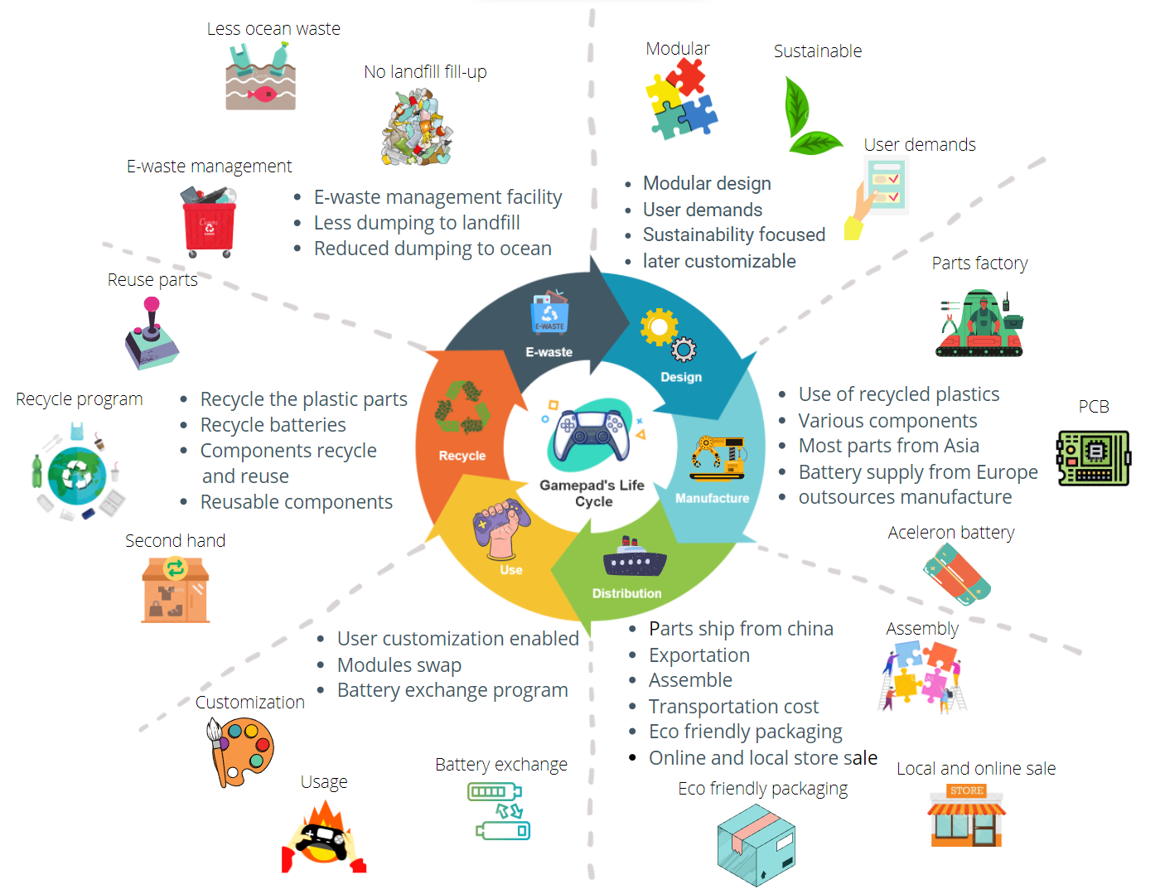

*Figure 7: Life cycle analysis (LCA) of a gamepad*

## 3.1 Functional unit

The functional unit considered in this study is a standard joystick, of which components are mainly produced in the People's republic of China and used and assembled in Europe. The device has 15 buttons, 2 joysticks, 2 vibration motors, one unit lithium-ion battery. Here, the battery is considered to have 300 to 500 charge cycles before the change is required, which depending on the use might be 2 to 3 years. The thumb sticks are rated to have an operating life of 2 million inputs. But the main advantage here is that the unit will not require a change if one of the components fails.

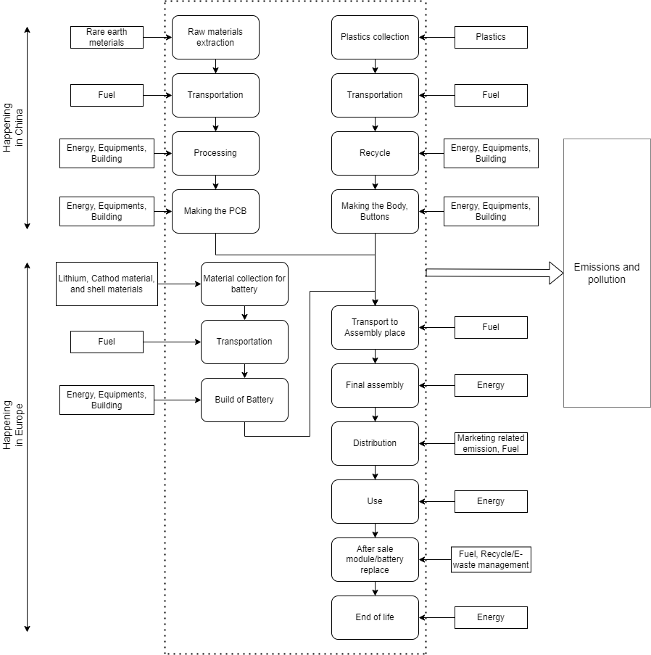

*Figure 8: System boundaries and emission factors of a gamepad*

## 3.2 Scope and System boundaries

The current study's coverage consisted hence a typical LCA throughout cradle to grave, i.e., out from extraction of various resources utilised in the creation of a gamepad device through the device's ultimate disassembly and decommissioning and e-waste management operations at the end of its life. This system boundary is illustrated in the Figure 8 of this report. Other areas and nations (mainly China) finished the manufacture of the product phase. Land as well as plane haulage through other areas and nations were removed out from transmission stage of analysis, leaving only maritime commerce (because of the unavailability of miles lengths for sea transport, the study relied on linear measures connecting Europe and import locations). For this gamepad the use stage is mainly constrained to Europe. Here, the product will be supported by customer service to replace or customise the components/modules of the unit. Battery replacement is done on collection of the original old battery from the user and proper recycle facilities are provided to it. When joysticks approach the limits of their useful lives, they are usually treated in one of two ways. Authorities and corporate units are primarily incinerated in Europe, however other discarded PCs, particularly those from individuals, are often taken to recycle/upcycle/downcycle or disposed in a treatment facility. Nevertheless, there were no good numeric information on e-waste transmission processed in the informal recycling sectors.

## 3.3 Life cycle Inventory

Like in many examples, obtaining appropriate Life cycle inventory information for the research proved to be most critical due to the corporations manufacturing this sort of gaming device's utter unwillingness to share data on their individual elements and procedures. As a result, an "inverse technique" was utilised to recognize these parts and systems. Proximate analysis can be used to get a somewhat more thorough characterization if required. In this study, the following stages of the lifecycle of the gamepad is considered. Each of these steps of the LCA is also described below:

1. Emission aspects
2. Raw materials collection
   1. Electric parts raw materials
   2. Wrapping materials
   3. Recycled materials
3. Gamepad production
   1. Parts production
   2. IC fabrication
   3. Battery production
4. Transportation and distribution
   1. Parts transference
   2. Assembly
   3. ICT manufacturer support activities
   4. Distribution
5. Use
   1. Gamepad use
   2. Associated use factors
   3. Disassembly and Repairing
6. End of life treatment (Check downloaded paper)
   1. Recycling
   2. E-waste

### Emission Aspects

The distribution system for energy and resource generation is included in the emission values since it may have a substantial environmental influence on the overall findings. Figure 8 illustrates the system boundaries and emission factors of the gamepad. There are mainly two locations on which the emission aspects are considered: People's republic of China, and Europe. The manufacturing energy mixture is predicated on the providers' regions for main data. Power mixtures for secondary sources are determined by the information's embedded places. Manufacturer data was utilised to calculate an emission factor that was near the world mean for PCBs and batteries in particular. Despite the fact that the evaluated items are designed for the European market, a global mean emitting component was used for the usage stage.

*Table 1: Impact indicators (Ercan et al., 2016)*

### Raw materials collection

#### Electric parts raw materials

Of the several components of the gamepad, the PCB (Printed circuit board) is one of the main components that require rare earth metals. PCB raw materials are extremely important in printed board production, and the essential fundamental building ingredients are known as PCB substrate materials. It was crucial in determining the structure's makeup as well as the copper covered laminate's properties. Pre-impregnated elements, copper foil, substrates, and ink are perhaps the most common printed board’s raw materials used in PCB production. The most common foundation is a fibreglass strengthened epoxy polymer substance with a foil bonded solely on a single or both faces. PCBs made of paper-strengthened phenolic resin with copper foil attached are substantially cheaper and are frequently used in household electronic components. The substrate, also known as CCL, is a PCB consisting of various characteristics and thicknesses of raw materials that is adhered to with pre-preg & copper foil adhesive at isothermal conditions. Copper foil's principal use is to create up and down line conductors for multi-layered boards. It can be used with pre-preg while under a specific temperature and pressure. Copper circuits are coated with a tin-lead coating to prevent oxidation. For superior properties, contacting Tin-lead, nickel, and gold are all used to sheath the fingertips. The primary agent and curing agent, resins, additives, colourant, solvents, & helper dissolvable are the components of ink. Solder shielding and circuit protection are two functions of ink. Other components such as resistor, capacitors, transistors also require rare earth materials like silver, copper, gold, silicon, lanthanum, cerium, neodymium, samarium and others. Environmental issues, water consumption, aquatic eutrophication, and photochemical oxidant generation are all influenced by the basic materials used in microcontrollers.

#### Wrapping materials

Approximate packing material volumes of components as well as actual delivery were calculated using manufacturers conditions plus variables that indicate the wrapping material weights in proportion to the component or gadget number. Because some components, like the PBC, are much more delicate, these necessitate more packing and thus have a larger wrapping factor. Here, Metal, polyurethane foam, polyurethane timber, chipboard, and cardboard are some of the substances used in wrapping.

#### Recycled materials

Here we will mainly use recycled materials for two different cases. For the plastic shell body and parts of the battery. For making a battery we will require lithium, graphite, cobalt, nickel and manganese. When evaluating raw material deposits, two factors must be considered: first, the resources that are usually accessible on the globe, and second, the deposits that can be harvested cost-effectively utilising modern tech at today's market pricing. Here, in our case we have a third factor as we will use recycled elements. This will help us work towards our sustainability goals as the need for building ingredients for batteries are skyrocketing (Abdelbaky et al., 2021). There are factories in Germany like Umicore that has plants that can generate up to 7000 t of battery mass annually, Volkswagens factory which produces up to 1500 t of battery mass every year. In the process of recycling batteries these plants can recover 100% of the total of the lithium, nickel, manganese, & cobalt, as well as 90% of the aluminium, copper, and plastic (Backhaus, 2021).

*Table 2: Recycled batteries proportion by weight recovered*

|  |  |  |
| --- | --- | --- |
| Recyclable material | Proportion by weight [kg] | Percentage () |
| Electrolyte | 37 | 9.25 % |
| Graphite | 71 | 17.75 % |
| Manganese | 12 | 3.00 % |
| Aluminium | 126 | 31.50 % |
| Nickel | 41 | 10.25 % |
| Lithium | 8 | 2.00 % |
| Cobalt | 9 | 2.25 % |
| Plastic | 21 | 5.25 % |
| Copper | 22 | 5.50 % |
| Steel | 3 | 0.75 % |
| Electronics | 9 | 2.25 % |
| Residual | 41 | 10.25 % |

The re-use of obsolete batteries in industrial systems might lengthen its life span until is the need to recycle it. There really is no actual work as to how many batteries would fulfil the criteria for secondary use in terms of residual storage capability and serviceability at this time. Generally, the second-life notion is only appropriate for situations where outdated, low-energy-density batteries may be utilised. Furthermore, concerns like standardisation and warranties must be addressed.

The other main component that would be recycled is the plastic body. But as we know all the plastics are not recyclable. Plastics are categorised per resin type, or just by colour, before recycling, perhaps through a manual process or by automated computerised systems. After classification, Mechanical recycling, which includes rinsing, crushing, and smelting the plastic, as well as chemical recycling, which requires disintegrating the plastic to monomers to form new polymers that may be recycled, are the two main methods for recycling plastic. The most recyclable plastics are polyethylene terephthalate, polyethylene that has high density and polypropylene. If the resin score of a plastic is too low, it is usually not recycled. The way plastics are created can affect their recyclability; thermoplastic polymers contain polymers which create undesirable chemical connections and can never be recycled, but thermoplastics can be melted and moulded again.

### Gamepad production

The fabrication of integrated circuits is characterised as a resource-intensive operation that consumes a significant amount of energy and resources also has one of the largest effects on the environment for unit of mass of any standardised product available today. The production of the PCB board will be done in Shenzhen Mincom Technic. There are 3 types of printed circuit boards, one is one-sided in which all the components are primarily placed on the one side of the board, here if the quantity of components is too high then those are put on both sides of the board, which is called double-sided, drilling holes in the substrates in appropriate places and coating the inside of perforations with a conductive substance are used to provide electrical contacts among the circuitry on either side. and finally, there is multi layered on which the circuits are divided by levels of shielding. For this gamepad we will mainly incorporate the double-sided design as the all the buttons interface and vibration motors connection will take up the upper portion of the PCB. The traditional "thru holes technique" or the modern "surface - mounted technique" are used to electrically link parts on a PCB to the circuitry. Every part includes tiny wires, or leads, that are driven into tiny holes in the substrates and attached to connect points in the circuitry on the other side via through hole technique. With surface - mounted technique, each component's legs make direct interaction with the board. Though surface - mounted technique necessitates more attention in component placement, it does away with the time-consuming drilling procedure and the spatially connection pads that come with through hole technology. So, here we are using a surface-mounted technique. Other small modules such as the Bluetooth module will also be sourced from the same company.

*Figure 9: Biodegradable, bio-based and composite plastics (EEA, 2021)*

The recycled plastic housing will be manufactured in the Henan green polymer factory. The production of plastic here would be eco-friendly and pollution free as they expertise in biodegradable and recycled plastic materials. There are a few steps that are followed to recycle the plastic. After collection and sorting the plastics are washed to remove all the impurities that are with the collected plastics that can thwart the recycling process or completely ruin the batch. After cleaning the next step is shredding. The plastic is then passed into choppers, that crush it into absolutely tiny parts. Unlike solid plastic, these finer bits can be reconditioned for repurpose in next stages. The shrunken plastic parts can also be utilised in disparate products with no need for any more operation. Tearing the plastics to small parts additionally makes it simpler to locate any pollutants that have remained. This is particularly literal of pollutants such as metals, that might not have been removed by cleaning but may now be conveniently collected with a solenoid. After this the plastics are then moulded to make our desired gamepads shell.

*Figure 10: Stages of plastic recycling process (Suez, 2022)*

The cap of the buttons and other plastic parts that don't have electrical parts will be made from the same recycled plastics. Manufacturing of these plastic parts requires the most amount of the energy in comparison to the other stages of these parts’ life cycle, thus they emit most granular, liquid and gas emission in this stage of the life cycle. The buttons & the joystick will be shipped from Shenshijia Electronics Co. Ltd. This company is chosen for its quality buttons and joysticks.

*Figure 11: Recycled battery manufacturing process (Gaines, L., 2018)*

Unlike all the other parts the battery will be manufactured from a European manufacturer. The reason behind it is that we estimate a better demand for the battery and the manufacturer that we have selected is the most sustainability focused than others. We will source the battery from Aceleron energy. The company incorporates a sustainability focused mindset while producing these batteries as they use Recycling and AI technologies to manufacture their lithium-ion batteries.

### Transportation and distribution

After production the components that are manufactured from China will be shipped to our European Wearhouse. There are two packaging phases in here, one while shipping from China and another after the assembly. In both of the cases we will make use of plastics free, eco-friendly, recycled materials, so the main focus would be to make the packaging materials as sustainable as possible. Moreover, there would be manuals and other necessary components of the gamepad inside the final packaging. This method features a straightforward design that is both cost-effective and environmentally friendly. The final assembly is done in Europe. Here, the energy required, general waste, emissions to air, land and water is considered to make the procedure as environmentally friendly as possible.

The transportation of the components of the gamepad also needs to be as sustainable and cost effective as possible. To achieve that target we will primarily try to ship the components via waterways and avoid air and road transport as much as possible. According to (Hillebrand, 2022), selecting a primary mode of transportation is a major choice that has a significant influence on elements such as delivery speed, shipping costs, and delay/damage risk, as well as climate concerns. They also say that it is the most energy and carbon efficient way to ship products from one place to another as it takes far less power to get moving. Even though maritime moves are more prone to be stalled by poor weather and are typically slower, however what they lack in pace, they more than compensate for in reach. Currently, one may carry cargo to practically any location by water, as there is almost always a main port close. Additionally, for whatever amount of cargo, sea freight is extremely cost-effective. Huge amounts of packaged products or large cargoes can be transported by barge across long distances or small distances at a cost that is typically unmatched by other modes of transportation. The battery part of the gamepad would be transported via road transportation. It is one of the most common, quick, and easy mediums of transportation. Furthermore, around ¾ of all the goods movement in Europe is done via this medium and our battery would be made in Europe. This way of transport has the benefit of a flexible time frame, reduced documentation, and numerous choices of vehicles. Even though here the carbon emission is pretty high as the fuel demand is pretty high in comparison to shipping, it can be compensated if we use electric vehicles as it is becoming very common day by day.

After we receive the product via shipment the product is then assembled together in our European warehouse. The amount of energy used, air, soil, and water polluted in this stage of the LCA is considered. After assembly is done then comes actually selling and marketing the product. Our target here would be to market mainly via different digital marketing platforms such as, endorsing youtubers and twitch streamers, regularly maintaining blog posts on the website, Facebook page, marketing on Instagram. The environmental impact of these activities is very minimal. Additionally, there would be ICT company support activities such as running a main office, business related travels. Here it is assumed that all the gamepads require the same amount of support activities, and it is added based on the sale volume. Final distribution of the products comes at this stage. We would mainly sell our product on online marketplace via our website, and via third party online marketplaces like amazon and eBay in order to minimise the GHG emissions of our distribution network. Even though there are concerns whether these mediums are actually that much eco-friendly or not we would try to minimise it via packaging the product in an extremely simple way. Moreover, for all the products we would sell on amazon, from 2008, Amazon have collaborated with companies to enhance packaging and decrease waste, reducing packing weight by 27% & eliminating more than 810,000 tonnes of product packaging, which would help us work towards simple environment friendly packaging.

### Use

During the use of the gamepad there are actually a few cases in which energy would be consumed and carbon would be emitted. First of all, while using the gamepad if it is used directly via cable connection it would consume direct energy from the device and thus from the grid, if it is used wirelessly, it would consume battery power. Typically, this gamepad would last for around 8-10 hours of continuous gameplay. Here, if we calculate how much energy is consumed while charging the gamepad, we can easily find out the carbon emission and environmental impact of the controller. Here, it is estimated that a typical battery would last for approximately 2-3 years, after which the user can easily change it as it is connected like a module of the gamepad. This is also true for all the other modules of the gamepad. One thing to note here is, energy consumption considered here is based on the reasonable use case scenarios.

Here, the modular construction of our gamepad would add considerable contribution to the environmental sustainability aspect as it would require much less energy and is made out of mostly recycled materials. In the use case the gamepad’s case would not produce any extra carbon as it is made out of the sustainable materials in the first place.

### End of life treatment

We propose to decrease and recycle the materials we use by adopting tight recycling requirements (final phase) throughout the earliest stages of the project to preserve resources, fight climate change, as well as establish a circular economy. End-of-life-treatment prospects for the gamepad are modelled using (Liebmann, 2015), which studies regional and worldwide waste streams in order to put up end of life treatment situations (As manufacturing part of our product is done in Asia, transportation via sea and usage is mainly in Europe). Liebmann mainly tries to approximate provincial trash streams notwithstanding the inconsistent dataset formats as well as major changes in fidelity among overall scrap info of disparate nations. Gamepad quantities are utilised to measure every nation's forecasted proportion of generated trash in the area categorising. The framework considers the amount of scrap created in the area, and trash import and export.

If the controller fails, the first solution is to change the specific module that is faulty. Upon request of a module, the new module is delivered, and the faulty module is subsequently collected from the user to properly dispose/recycle it. This is absolutely essential for the battery module as it can create some serious e-waste hazards otherwise. If the whole joystick fails it is suggested to the customer to make the request of waste recycling, but if the user opts to throw the gamepad away, it still has much lower environmental impact as the modules can be used in the next gamepad.

# Gamepad design and tools

*Figure 12: Render Image of the gamepad in SOLIDWORKS*

Designing and modelling a product in 3d is very important as it provides a more precise representation, accurate indications of dimensions and distances of a product. Experiments can now conveniently come to life on a computer screen thanks to advances in design and modelling software. Modern practices have brought in a new breed of deeply featured apps, redefining what can be created in a given amount of time. Many flaws connected with outmoded techniques have been addressed by 3D modelling, which has boosted effectiveness across design engineers. Formal prototype, which involved the fabrication of actual versions years ago, is sometimes preceded by 3D modelling (Zhang and Coombs, 2011). It's tough to gain a good sense of a design's form factor with traditional 2D modelling. As a result, designers are forced to produce model after model to represent any significant design change. As a result, high resource expenses are incurred, which are amplified when numerous items are developed at the same time. Companies would probably prefer to conserve these raw resources for actual manufacturing in the end. They will not be replenished over time. Additionally, when users can put additional layers to ideas, it becomes much simpler to build on easier handling and discover design flaws (Massie, 1998). Take, for example, stress mapping, which uses coloured topography to show regions of concern. This is critical for items that are subjected to various stresses such as heat, stress, and torsional. Complex forms are really the new standard in today's creations, which include a range of diverse geometries. Developers may analyse each tiny detail of a product using unrestricted model inspections, guaranteeing that any flaw is identified and corrected for the next version. Furthermore, On the cooperation side, tiny details make it simpler to communicate the subtleties of a design. Creative crews are no longer divided into compartments. They can interact with the other team members and stakeholders without difficulty. Coming to bat for a model involves the presence of all necessary components in the schematic. 3D models allow teams to add more information, making it easier for everyone to stay on the same path.

## 4.1 Tools

For designing/modelling products there are quite a few tools and software available. Here, we have discussed a few of the most popular ones:

#### Fusion 360

Fusion 360 enables remote communication using real-time collaboration capabilities like comments, annotations, and much more. Team members don't have to be out of sync just because they're not in the workplace. Cloud software allows you to create models after design without having to be at the desk all day.

Fusion 360 is suitable for both experienced and novice design professionals. Fusion 360 has a long array of functionality in addition to the conventional modelling tools. Parametric design, electrical layout, 3D printing features, and more are among the options. It also comes with a number of plugins as well as addons to help you streamline your 3D modelling process.

#### SOLIDWORKS

SOLIDWORKS is a complete 3D programme that aids in the designing and manufacture of products. The programme is versatile, allowing users in a variety of sectors to design whole endeavours architecture to hardware emulate product functionality within the application.

#### Autodesk 3D

This 3D modelling programme is widely used in the film, television, and video gaming industries. Autodesk 3D is a comprehensive programme that includes 3D modelling, texturing, and effects, as well as computer animation plus dynamism and 3D renderings.

## 4.2 Modelling

For this study SOLIDWORKS is utilised to design the gamepad. Design details of the gamepad is given below:

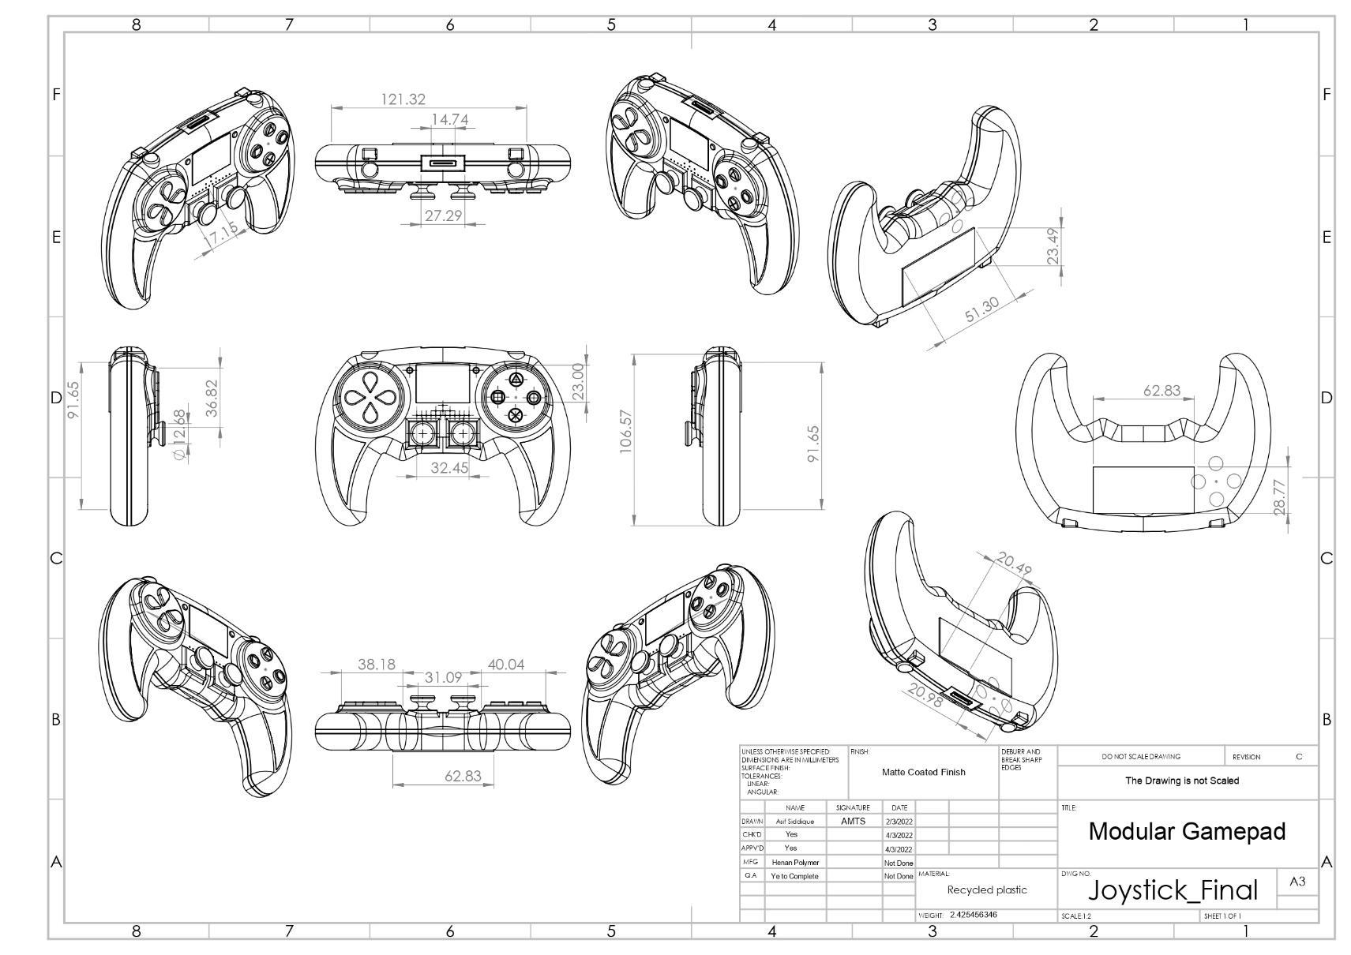

*Figure : Scratch and dimensions of the gamepad*

Figure 12 illustrates the dimensions of the gamepad and the modules via drawing of the gamepad in SOLIDWORKS. The ability to exchange pieces without impacting the remainder of the gamepad is a benefit of detachable gamepads over non-modular gamepads. This element enables the whole life cycle analysis to be optimised. Furthermore, modular gamepads have several removable parts. Customers can swap pieces of the suggested gamepad modules whenever they desire without requiring technical support. A graphic image of the designed gamepad is given in figure 14.

The gamepads front design can be seen in the above figure. Here we can clearly identify the modules that are detachable. In the front there are in total 4 detachable modules:

* + - 1. Right action buttons module
      2. Left action buttons module
      3. Right joystick module
      4. Left joystick module

*Figure 14: Gamepads front view in SOLIDWORKS*

These extra modules will be sold separately to the consumers mainly via our website. There is also another module of battery in the back which can be easily seen in the following figure,

*Figure 15: Back view of the gamepad in SOLIDWORKS*

From the figure 15 we can see that there is a portion where the battery goes in, that part of the controller is detachable, and this part would also be sold via our online store and website. Other views of the controller are included in the appendix part of the report.

## 4.3 Sustainability aspect

One of the modules of SOLIDWORKS is a sustainability module that allows for calculating the environmental impact of a gamepad on the environment. In there we can fill-out different criteria to calculate the environmental impact of the joystick. In this case we selected our manufacturing region to be Asia and use region to be mainly in Europe. For this we have to define the material that is used to make the product. Recycled plastic is selected as the main material of the gamepad. Here, elastic modulus value and units are defined which represents the elasticity of the products material. Poisson’s ratio’s value and units are also given here, which basically indicators material deformation in a right angle to the orientation of external stress. Then shear modulus value and units are also provided, which is a measurement of a material's elasticity shear rigidity, described as the division of shear stress to shear tension.

Values and units of mass density, tensile strength, compressive strength, yield strength, thermal expansion coefficient, and thermal conductivity are provided as the recycled plastics properties. After the definition of the material the manufacturing process is set to custom, print of the gamepad is set to yes and powder coated.

Here, the transportation part of the life cycle is also defined to calculate the sustainability report, where most of the time the medium of transportation is selected waterways, road transportation is also considered in this phase. Furthermore, the end-of-life treatment of the product is selected at this stage, which would be mostly recycling.

*Figure 16: Material, transportation and end of life aspects of the product in SOLIDWORKS*

After providing all these values we get the following results from the SOLIDWORKS sustainability report:

*Figure 17: Sustainability report of SOLIDWORKS*

As we can see from the figure 16, the manufacturing part of the product's life cycle had the most amount of environmental impact in terms of carbon footprint, total energy consumption, air acidification, and water eutrophication. Material was the second most carbon emitting factor among other life cycle aspects. Here, transit, and end of life aspects are contributing the least in terms of power consumption plus GHG emission. We can also observe that the total carbon footprint is 1.5 Kg CO2e for each controller, and if we convert that to the total energy consumption, we get 26MJ. Here, air acidification and water eutrophication are mainly happening in the manufacturing stage. Total 0.013 kg of SO2e is emitted to the air acidification process and a total of 6.7E-4 kg of water pollution is done via PO4e. The original sustainability report is added to the appendix section of this report.

# Business Analysis

## 5.1 Business model

The business model is addressed in this part, as are the key organisational building pieces that might make the company lucrative. The company's fundamental purpose, and hence the worth to be provided, is to supply ecologically responsible, high-quality sustainable gamepads with proven durability to the European gamers at a reasonable price. Businesses' capacity to extend their business without jeopardising environmental safety will be considerably enhanced as a result of this. A great business model is the foundation of a triumphant company. A business model adds merit to a firm by providing what its consumers desire, which might be a goods or services. The nine aspects depicted in the business canvas in figure 18 is form the foundation of our company model. This is accomplished using the business model canvas (Osterwalder, 2011), which aids in the identification of consumers, value propositions, infrastructures, and financing.

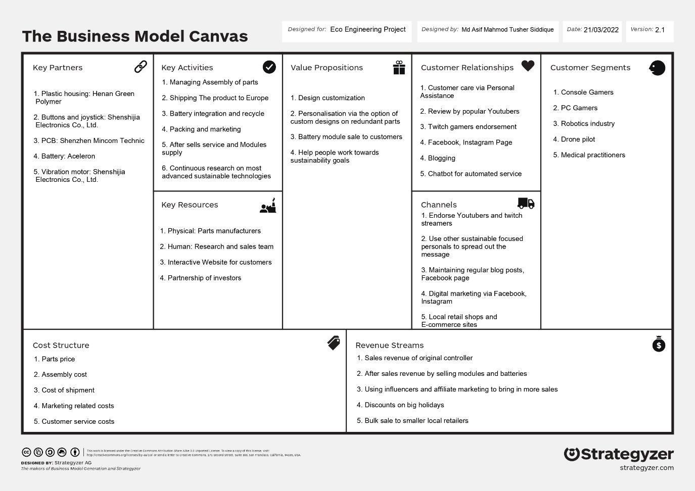

*Figure 18: Business canvas of the controller*

### Key Partners

Key partners are the relationships that corporations have with another businesses in order to ensure their success. In terms of critical relationships, the vendor network is the most significant. Some companies serve as hubs in larger supply chain network. Since they link supplier relationships, ties are critical to the business model. Businesses develop alliances for a variety of reasons, including preventative measures and resource acquisition. Vendors should create partnerships to ensure reliable supplies. Strategic alliances, that have become a bedrock of many company models today, are the foundation of a business model. The essential actions describe what an entrepreneur or businessperson must do to evolve and give a unique selling proposition, expand to markets, cultivate customer relations, as well as earn money. Key activities of a business include, in the company growth process, creating ties with collaborators, determining what inspires the buyer, the clients’ problems, and the location of the rival companies, generating leads in sales.

In our case our key partners are Henan green polymer for supplying plastic housing or casing, Shenshijia Electronics Co. Ltd for buttons, vibration motor, and joystick of the controller, Shenzhen Mincom Technic for PCB, and Aceleron for battery.

### 5.1.2 Key activities

The actions that a corporation must do in addition to operate are known as key activities. It extends well beyond than that. The crucial actions that business needs to do to provide the core competencies to clients are called key activities. It's critical to identify the primary tasks required for business value. It's also crucial to identify which vital chores companies need to complete on your own. Whenever confronted with depreciation as well as disruptive market developments, altering those may be a significant source of corporate innovation strategies.

*Figure 19: Key activities of Business model canvas (Hubspot, 2021)*

Key activities for the gamepad involves managing the assembly of the parts, shipping the products to Europe from Asia, battery integration and recycling, packaging as well as marketing, after sales services plus modules supply, continuous research on most advanced sustainable technologies and others. Here, merchandising, integrating components, creating modules, packaging, and delivering the gamepads to our different warehouses or online e-commerce platforms like amazon are all key processes even before product reaches clients. Then there's after-sales service, which includes customer assistance, collecting client complaints & recommendations to enhance the device, and speaking with our R&D department, which is working around the clock to bring innovative advancements to our gamepad.

### Key resources

Key Resources are required in any business plan. Useful materials allow any business to establish plus market a Marketing Strategy, extend to additional consumers, strengthen bonds with concurrent consumers, and create revenue. Contingent to what category of marketing plan, distinct Key Resources are needed. A semiconductor producer needs massive production houses, but a microprocessor architect is mainly interested in individual assets. Material, economic, technical, & personal assets are all important assets. The corporation can either even own/lease critical resorts or collect them from commercial alliances.

There are mainly 4 types of key resources: (i) Physical: Production lines, facilities, transportation, machinery, devices, juncture structures, plus supply networks all are within this type. In our case part manufacturers are the key physical resource. (ii) Intellectual Property: Trademarks, private information, trademarks and patents, collaborations, plus membership sites are all becoming more crucial parts of a triumphant business plan. Ip rights sources are hard to create, but if done once, they might be quite treasures. In our case partnerships with other companies, Interactive website, gamepad design is key intellectual property. (iii) Human: Every organisation requires qualified personnel. In expertise and artistic businesses, for instance, people resources are critical. Our most valuable human assets are technical experts, security guards, as well as other machine operators. We would also leverage e-commerce platforms such as Amazon's human resources for delivering the product. (iv) Financial: For employing important workers, many business models necessitate monetary capacity and/or economical guarantees, including funds, bank loans, or even a share options fund. In our case we'll utilise cash from shareholders, a bank overdraft if necessary, and investment money.

### 5.1.4 Value propositions

Consumers selects a product above others by dint of its Value Proposition. It addresses the consumer’s issue or meets their requirement. Every Unique Selling point consists of a scrupulously considered scope of items plus solutions adapted towards the demands of a Specific Audience. Here, the Value Proposition is indeed a assemblage of precedence which a company issue for clients.

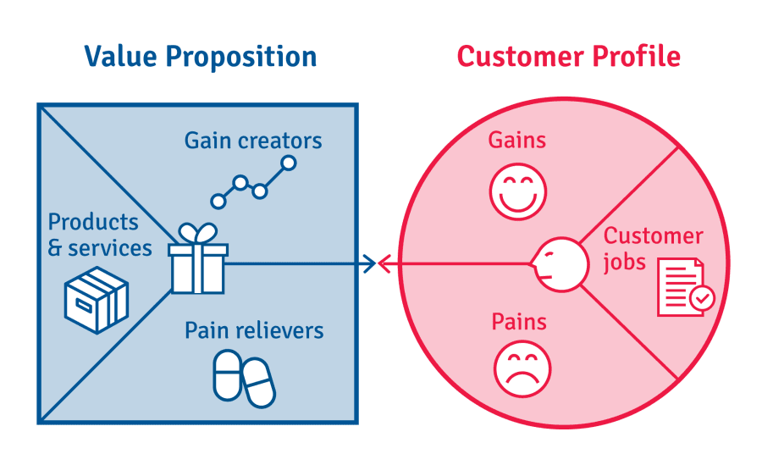

*Figure 20: Value proposition (B2Binternational, 2020)*

Gamepad market is fast growing, and as the market grows, so will the producers' profits. Numerous reasons, including as the exorbitant price, poor quality, as well as negative effect to the environment, remain major concerns. This customizable gamepad will help to overcome many of these issues. Think about what happens whenever a part of the gamepad somehow breaks. Current gamepads have a significant risk of becoming e-waste, requiring the consumer to purchase a new gamepad. Since our gamepad is detachable, it is unlikely that the entire gamepad will become useless. It is very common that a part or a button of the controller somehow breaks or stops working. As a result, the customer might discover certain modules within excellent functioning order. Rather than purchasing a new gamepad, customer can buy just the broken gamepad parts, conserving costs and minimising environmental impact. Furthermore, we shall employ recycled plastic as well as LIBs, which are much more environmentally sustainable substances. Additionally, we want to make more people, especially young generations aware of the sustainability aspect and as majority of the gamers are mainly young, if we are able to properly transfer the awareness of the environmental impacts of different products it would help a lot towards our sustainability goals.

### 5.1.5 Customer relationships

Every business must define what sort of relationship it wishes to have with its specific audience. These types of media help companies form connections. Clients can be obtained, retained, or revenues could be raised by connections that span from individual through robotic, commercial to protracted. Client Relationships a business establishes have a significant impact on the whole client engagement. There can be 9 types of consumer relationships. In our model various aspects of customer relations are included such as customer care via personal assistant, review by popular youtubers, Twitch gamers endorsements, Digital marketing via Facebook/Instagram, regular blogging from our website, and chatbot for automated services.

We don't just want to receive consumers. Our company would like to retain him around as well as help each other flourish. Our clients are more likely to continue together as they can repair faulty components without having to buy a new gamepad. Moreover, there's the viral cycle, wherein former clients would recommend our gamepads to prospective consumers through videos, social media status updates, plus gratitude.

### 5.1.6 Cost structure

This core component details the most important expenses incurred when following a specific company plan. Costs are incurred when developing as well as adding content, preserving Client connections, plus producing money. However, certain company strategies are much more cost-focused over others. Costs must, of course, be retained to a nadir in any business strategy. However, certain business models value reduced architectures more than others. As a consequence, it is indeed useful to understand the different categories of pricing in marketing strategies.

*Figure 21: Cost structure of the company*

Here we mainly divided the cost structure into two parts, costs that happen one time like manufacturing of a product, and continuous expense that will be recurring every month. After conducting exhaustive industry analysis, we arrived at the figure 21 estimate. We'll require recurrent charges like month-by-month flow of equipment to build our gamepads, as well as leases, utilities, as well as employees. We will invest a significant amount of finance in promoting our gamepad both when it first enters the market as well as before subsequent refresh product announcement. We classified distribution costs as a one-time expense since we would hire a 3rd party operator to supply our goods in huge quantities on an occasional basis.

### 5.1.7 Customer segments

Briefly said, client segments are really the collective of individuals or businesses to whom companies would like to offer their merchandise. This is the primary and possibly critically significant phase in developing a Business Model, because the specification of such a piece is very important to the development. Consumers can be subdivided based upon the requirements, habits, sociodemographic characteristics, hobbies & motives, as well as other commonalities. Throughout its commodities, an organisation might choose to serve a particular or several categories.

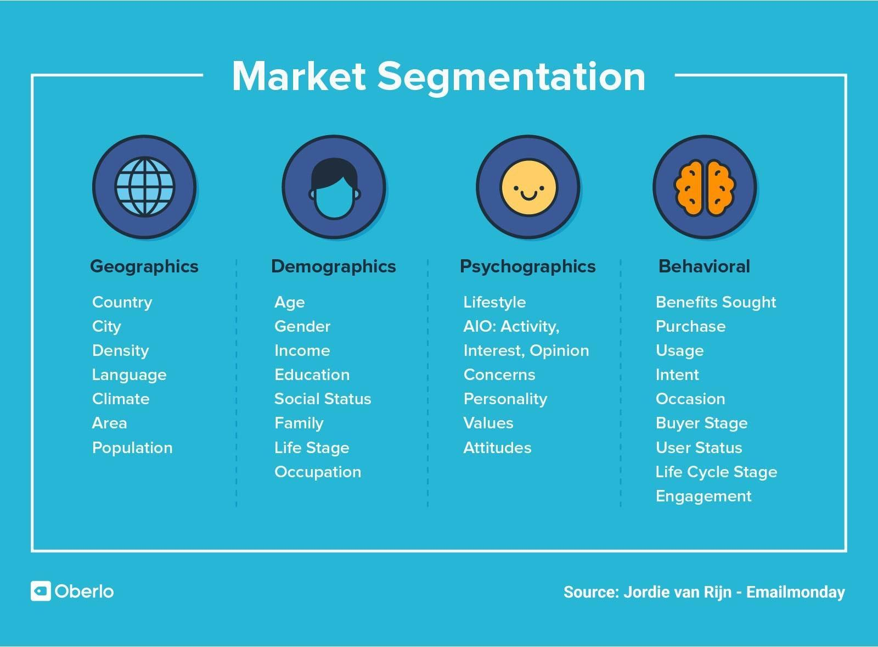

*Figure 22: Customer segment of businesses (Investopedia, 2021)*

We understand our clients' requirements as well as aspirations, so therefore design of gamepad is made accordingly. For our gamepad customer segments are, console gamers, PC gamers, Robotics industry, Drone pilot, medical practitioners, and other controller users.

### 5.1.8 Channels

The business model canvas construction component helps a corporation develop their media strategy as well as market offer for a specific target demographic. Recognizing key platforms via that a company engages with its own clients is the first step in making a quality experience for customers. Streams could be viewed in many different perspectives. A channel can relate to a corporate supply system or a marketing region around supports & challenges on the diagram. The movement of commodities from suppliers to customers is accomplished through sales channels. There are several uses for streams, such as: Increasing client engagement of the brand message. Giving clients a means to evaluate a business's value offer. A platform or program which allows users to buy specific products.

In our case we would mainly try to sell our products via endorsing youtubers/twitch streamers, using other sustainable focused personals to spread out the message, maintaining regular blog plus Facebook pages, digital marketing via Instagram plus twitter, local retail shops and e-commerce sites. Our first strategy involves sponsored ads at prominent platforms such as Facebook, YouTube, or Instagram, as well as providing extra copies to well-known twitch streamers, youtubers. In order to market the goods, we'll start with our website as well as amazon and then move on to local stores. Amazon would transport these gamepads, and then we will maintain after-sales activities such as client care, buyer complains, plus reviews via both webpage & Amazon. If necessary, we might employ alternative following vendors.

### 5.1.9 Revenue streams

The money earned from every one of an industry's Target Markets may be mapped out during this portion of the palette. The construction component indicates the money earned from every Specific Audience rather than the revenue. Remove expenses out from income generated by each Target Markets to arrive however at figure. Revenue Streams are critical in a customer-centric company strategy. Therefore, in order to successfully build Sources Of income, it's critical to take a respondent’s indicated thought about what benefit the consumers are expected to pay. The items or solutions will be valued appropriately depending on its projected value in this manner.

*Figure 23: Revenue streams of the company*

In the case of our gamepad our main revenue streams would be via sales of the original controller, after sales revenue by selling modules and batteries, using influencers and affiliate marketing to bring in more sales, discounts on major holidays, bulk sales to smaller local retailers. Our primary objective is to offer our gamepad in modules, allowing users to select the power of batteries and customised personal design and desire. As a result, instead of providing the gamepads as a complete package, the majority of the profit would make from vending component pieces. We want to develop as well as market our unique apps for control customization of our gamepad. The site, gamepad modules, and battery sales are also expected to generate some income. Figure 23 depicts an estimate of the proportions we would like to receive through various product kinds.

## 5.2 Supply chain

### 5.2.1 Supply chain strategy

A company's competitiveness is acquired either from their capability to save expenses and otherwise deliver a specific experience. The detachable gamepad is primarily a unique device that offers a professional approach for consumers to decrease wastage. This device's value would be not only ecological, but also economic. A distribution network management is created with the device's economy into consideration; as a result, one of the distribution network plan's main goals is to reduce materials collection, manufacturing, as well as shipping expenses. The distribution network plan is optimised not just for economic success and also for wastage & greenhouse gas emits reduction. A sound operating approach & inventories might enable the company to decrease its environmental impact. Contracting supply chains may also enable the company to save power as well as lower its carbon footprint. These steps including resource elements collecting, manufacture, shipping, then delivery would be delegated to reduce environmental impact. It enables specialist organisations to focus on individual activities while still allowing for manufacturing intention of meeting shifting requests. The distribution system may be made more efficient by selecting firms that specialise in gamepad manufacture plus production. E-commerce platforms like Amazon as well as Alibaba are fantastic supply methods. Amazon facilities offers inexpensive inventory and storage solutions, with the firm just paying for space used. This in itself saves money and makes the distribution network more reactive because warehouses may be adjusted as required.

Our key partners in Asia would provide all of the components of the gamepad, such as the plastic housing would be provided by Henan Green Polymer, Buttons, joystick, and the vibration motor would be provided by the Shenshijia Electronics co ltd, the IC would be provided by the Shenzhen Mincom technic and battery would be supplied by Aceleron. These components would come to our assembly warehouse. Then these assembled gamepads would be stored in different warehouses like our own and amazons. Then would be supplied to the customers on order. Here, amazon and Alibaba would manage their part of the supply chain. If a component of the gamepad fails, the customer can make a direct request via our website, and we would supply the component and subsequently collect the old one.

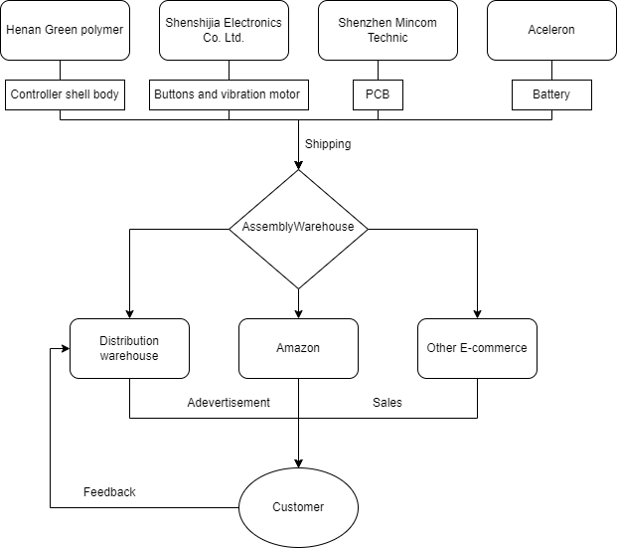

*Figure 24: Supply chain network*

#### Supply chain key activities

Gaming market is growing exponentially. Even though numerous small firms make controllers, just a few corporations dominate due to the high quality/durability they give. We on a different end would offer this modularity. Moreover, we anticipate that many more will follow suit with equivalent or better technologies. Nonetheless, being the first to marketplace would benefit us much, plus the Research and Development team would continue to expand in response to customer demands. There are a few primary activities that are connected to the supply chain of the gamepad. Certain critical operations must be completed in order for the distribution network to be efficient as well as environment friendly, as outlined following:

* Coordinated production as well as delivery that ensure quality, security, plus environmental friendliness
* Continual change in response to market conditions
* Continuous innovation, redesign, and R&D to complement customer demands
* Finance evaluation

#### Supply chain stages

So basically, we can divide the supply chain stages into 4 phases. These are illustrated in the following table:

*Table 3: Supply chain stages*

|  |  |
| --- | --- |
| Stages | Conducted by |
| Resource collection | Henan green polymer and other key partners |
| Manufacture | Henan green polymer and other key partners |
| Transport | White Rose International Forwarding Ltd |
| Distribution and storage | Our warehouse, Amazon, and other distributors |
| Retain | Initially no retail |

### 5.2.2 Market competition estimation

The market of gamepads and gaming industry is booming and is estimated to grow exponentially in the coming years. There is no major manufacturer that makes modular gamepads now, but this market is going to be very competitive in the coming years as more and more manufacturers become aware about the environmental aspect. Moreover, as many governments are putting pressure on the manufacturers to produce reusable and environmentally friendly green goods, especially in Europe, this space is going to get crowded in the near future. Here, as we are starting early, we will have a significant advantage and have the potential to become one of the bigger manufacturers of gaming products.

### 5.2.3 Risk assessments

There are certain risk factors that are associated with the production and sale of this modular gamepad. First of all, there could be seasonal demands like holiday seasons, when the demand would be much higher than average times. This problem is addressed in our future plan of the product as we already want to put more marketing campaigns during the holiday seasons and special vacations. Another one of the major risk factors could be the exchange rate of the money. As our manufacturer and distributors are from different parts of the world, at times the price of Euro or pound might decline subsequently, and we might require altering the expense strategies we set in here. There also could be other external factors like political situations which could significantly affect our plans. Like the recent ban of the USA on many products from China, the political environment might change at any moment, and we better be ready for it in advance. There could be other problems like local regional manufacturing requirements, patent registration and others.

One of the major risk factors for our gamepad would be tariff fees. As we are importing parts from a different region this can significantly impact the pricing strategy of our product.

### 5.2.4 Growth strategy

Whilst confronting competitiveness, the company plan must facilitate rapid growth. An expansion plan is developed in order to allow for development, diversification, plus potential takeover to maximise productivity & achieve a higher audience in order for the firm to continue through the future. Despite starting small, our objective is to expand our business and market. We will continue to expand our retail stores as well as facilities in all of the locations wherein our gamepads will be marketed. In our plan we divided the future growth strategy of our company in four phases, these are described below:

#### First phase

Disparate phases will be used in the company's primary distribution network segment. Obtaining resource elements would be the initial step. Construction as well as treatment would occur at the organisation's operational facilities in China in the 2nd level. At step three, the finished items will be housed. The parts will be transferred to the United Kingdom via cargo handling in step four, and then relocated to an assembly warehouse. After the assembly is done it would be moved to storage facility (Our warehouse and Amazon's). The product will next be advertised and supplied to customers. With development, alliances, plus effective advertising for green strategies, the distribution systems management would enable our strategic plan. This will continue to investigate for expansion opportunities, foresee its expected progression of international competition, plus meet rapidly increasing client expectations

Our primary starting location would be from the United Kingdom. As controllers are in high demand inside Great Britain, and we want to enter this rapidly expanding sector by 2023.

#### Second Phase

In the second phase of the business strategy, we would extend our business to other European countries. According to (Mordor Intelligence, 2022) Global videogames market was worth us$ 198.40 billion in 2021, and this is predicted to reach USD 339.95 billion by 2027, representing an annual growth rate of 8.94 percent between 2022 and 2027. Growing web access, greater smartphone penetration, as well as the introduction of high-bandwidth internet connection, have all contributed to growing gaming consumer demands throughout the world. These changes are most evident in Europe. Moreover, the European region is close to the United Kingdom, which would allow us to easily expand our business. For these reasons our second phase of the expansion is concentrated on Europe.

#### Third Phase

In this phase of the business strategy, we plan to expand our business to China and the United States of America. The People's Republic of China holds the biggest gaming market amongst all the nations of the world. Gaming market in the USA is in the 2nd place among all nations. Here, it would be very easy and convenient for us to expand in both of these locations. There are plenty of communication lines from the UK, Europe to America, and we are already making our parts in China, which makes the expansion process very simple.

In addition to these regional expansions, the firm will work collaboratively through government and legislative institutions in order to licence and patent various gamepad designs plus models. Partnering with insurance providers on employment, transit, plus company protection also will be discussed.

#### Fourth Phase

In the final phase of our business growth strategy, we plan to become a true international company by expanding our business throughout the world. In this phase our first warehouse and retail store will be built in India. With a huge population this market has the potential of becoming one of the biggest gaming markets. We also plan to open retail stores in all the major locations around the world.

Additionally at this point, the firm will focus on increasing earnings plus optimising operations in order to give clients with the best possible service & response. It will be accomplished by designating a dedicated salesman to each customer and providing a 24-hour hotline to respond to any queries or quotations that customers might have had. Furthermore, the firm will try to improve expense negotiations with vendors, explore other finance sources, as well as improve relationships amongst providers to achieve better resource materials pricing information.

## 5.3 Cost structure and budget

Pricing model plus budgeting are crucial steps in corporate strategy because they may assist discover instances where money can be saved. Which, in turn, makes the company extra appealing to shareholders since realistic profit predictions may enable the investors budget forward. This section describes the operating costs, the cut threshold, as well as the examination of potential opportunities.

The business's seed money will come through institutional financiers, federal grants, requests for venture investment from private equity, and primary investments from partners and friends. In the long run, in parallel to the income generated as selling expands, the firm will benefit from additional external financing such as crowdsourcing, Kickstarter events, as well as European commencement funds.

### 5.3.1 Cost Structure

#### Price Breakdown of each gamepad

Primary goal of the business is to collect 25,000 Euro as an initial investment. The manufacturing cost of each gamepad is set to 30 Euros, shipping cost of each gamepad's components is calculated to be 4.29 (2 for components of per unit from China to Europe, and 2.29 for delivery) Euros. Moreover, the budget for each month’s advertising is set to be 1000 euros. Cost breakdown of each of the gamepad is given below in table 4. The price of the gamepad is derived by adding the expense of manufacturing thousand units to the expense of shipping from China via cargo ships. Here 20% value added tax is also considered. As the average cost of a high-end Gamepad in Great Britain is roughly 60 euros, our approach provides a financial benefit to the client while also supporting a sustainable environment.

*Table 4: Price breakdown of gamepad*

|  |  |  |  |
| --- | --- | --- | --- |
| Component | Unit cost (Euro) | Percentage cost of final price | Price of 100 units (Euro) |
| Shell body | 3.65 | 7.30 % | 365 |
| IC | 4.1 | 8.20 % | 410 |
| Bluetooth and other modules | 5.2 | 10.40 % | 520 |
| Buttons and motors | 3.5 | 7.01% | 350 |
| Battery | 4.3 | 8.60% | 430 |
| Paint and others | 3 | 6.01% | 300 |
| Cost of unit | 23.75 | 47.50% | 2375 |
| Price after tax (20%) | 28.5 | 57.01% | 2850 |
| Transportation | 4.29 | 2.22% | 429 |
| Total cost | 32.79 | - | 3279 |
| Selling price | 49.99 | - | 4999 |
| Profit (Without marketing and others) | 17.2 | - | 1720 |

#### Human resources and governance

Initially we plan to start small with a few important members to govern, design, engineer, and market our gamepad. The salary structure of the governance and human resources employees is given in table 5.

*Table 5: Salary structure*

|  |  |  |
| --- | --- | --- |
| Role | Salary (Euro) | Share percentage |
| Chairman and Chief  Executive | 2500.00 | 17 % |
| Finance Chief | 2200.00 | 11 % |
| Engineering Chief | 2000.00 | 9 % |
| Marketing Chief | 2100.00 | 12 % |
| Production Chief | 2200.00 | 13 % |
| IT Chief | 1900.00 | 13 % |
| Other investors | - | 25 % |
| Employees | 1500 | 0 % |

### 5.3.2 Flow of Cash

Having a consistent cash flow is essential for a company’s performance since it allows it to satisfy its commitments, keep the stock, as well as satisfy client needs. Because our company is not yet operational, we have constructed a six-month speculative cash flow forecast.

*Table 6: Cash flow of the company*

|  |  |  |  |  |  |  |  |  |  |
| --- | --- | --- | --- | --- | --- | --- | --- | --- | --- |
| Cash flow (Euro) | | | | | | | | | |
| Item | Jan-23,  Starting | Feb-23 | Mar-23 | Apr-23 | May-23 | Jun-23 | Jul-23 | Aug-23 | Sep-23 |
| Gamepad sales revenue | 0 | 5,250 | 7,375 | 9,625 | 11,455 | 13,500 | 20,250 | 23,500 | 28,050 |
| Module sales revenue | 0 | 0 | 0 | 0 | 700 | 1,200 | 1,500 | 2,200 | 3,000 |
| Investment | 25,000 | 0 | 15,000 | 20,000 | 0 | 0 | 50,000 | 0 | 0 |
| Total revenues | 25,000 | 5,250 | 22,375 | 29,625 | 12,155 | 14,700 | 71,750 | 25,700 | 31,050 |
| Salary | - | 14,700 | 14,700 | 14,700 | 14,700 | 14,700 | 14,700 | 14,700 | 14,700 |
| Insurance | - | 4,000 | - | - | - | - | - | 4,000 | - |
| Warehouse rent | - | 1,400 | 1,400 | 1,400 | 1,400 | 2,900 | 2,900 | 2,900 | 2,900 |
| Utility | - | 300 | 300 | 300 | 300 | 700 | 700 | 700 | 700 |
| Marketing | - | 1,000 | 1,000 | 1,000 | 1,000 | 1,000 | 1,800 | 1,800 | 2,500 |
| Equipment | - | 20,850 | 15,000 | 0 | 0 | 0 | 0 | 0 | 9,000 |
| Total expenses | - | 42,250 | 32,400 | 17,400 | 17,400 | 19,300 | 19,300 | 23,300 | 29,800 |
| Net cash flow | 25,000 | -37,000 | -10,025 | 12,225 | -2,700 | -4,600 | 52,450 | 2,400 | 1250 |
| Cumulative cash flow | 25,000 | -12,000 | -22,025 | -10,225 | -12,925 | -17,525 | 34,925 | 37,325 | 38,575 |

From table 6 we can see the estimated cash flow of our company. We can observe that in the first month we receive an initial investment of 20,000 euros. When the sale of gamepads starts, we see a very small sale as a starting company. Moreover, in this month we have a lot of expenses as we need insurance and equipment for running the business. As a result, at the end of the month we see that the cumulative cash flow is negative. This trend continues till July, and in July we receive a big investment, and all the dues are paid and with the extra money in hand we invest more in marketing the product. Before that in June as the sale numbers increase, we would want to get another warehouse to operate our business. As a result, the utility and rent increase this month. By the end of September, after 9 months we expect to generate total sales revenue of 31,000 euros. In this month we would want to invest more on inventory as the business grows.

After these 9 months we estimate to have enough sales, experience, key partners and investments to jump to phase 2 of our growth and start spreading our business throughout Europe.

### 5.3.3 Balance sheets

Balance sheets provide a snapshot of a company's economic status at a certain juncture. This then displays a company's inventories and dues. The economic status of a corporation may be established by examining at its operating assets as well as dues.

The following is a potential growth for our company:

*Table 7: Growth of the company by each quarter*

|  |  |  |
| --- | --- | --- |
| Sale by the end of | Number of unit sales | Revenue increase from the first quarter |
| 2023 Q2 | 2100 | 85.71 % |
| 2023 Q3 | 3075 | 170.92 % |
| 2023 Q4 | 4300 | 278.85 % |
| 2024 Q1 | 5550 | 338.98 % |
| 2024 Q2 | 5900 | 419.82 % |
| 2024 Q3 | 6975 | 514.53 % |
| 2024 Q4 | 8025 | 607.04 % |

The following is the balance sheet of our company after first quarter:

*Table 8: Balance sheet after first quarter*

|  |  |
| --- | --- |
| Balance Sheet |  |
| Assets |  |
| Inventory Assets | 35,850 |
| Bank balance | 0 |
| Liabilities |  |
| Payable liabilities | 10,225 |
| Bank loan liability | 0 |
| Net asset | 25,625 |

The following is the balance sheet of our company after second quarter:

*Table 9: Balance sheet after second quarter*

|  |  |
| --- | --- |
| Balance Sheet |  |
| Assets |  |
| Inventory Assets | 45,850 |
| Bank balance | 37,325 |
| Liabilities |  |
| Payable liabilities | 0 |
| Bank loan liability | 0 |
| Net asset | 83,175 |

As we can see at the end of first quarter, we had some payable dues even though we had inventory assets. Then at the end of the second quarter we can observe that all the dues are cleared, and we have both assets and additional balance in the bank to extend our business and step towards phase 2.

### 5.3.4 Future prospect of the company

The gap between sales and expenditure determines revenue. To enhance profitability, we must either ramp up income or reduce expenses. For our company, a potential financial statement for the upcoming 3 years by each quarter is shown in the figure 25.

As depicted in the figure 25 at the end of first annum the business will have an estimated cash flow of 175,000 euros. After paying the value added tax and the investments throughout the year of 110,00 euros, in the next year we would carry a profit of 65,000. By the end of second year, we can observe that the same number is ramped up to 205,000 euros. And in the 3rd year that number augmented more than the previous years.

*Figure 25: Estimated profit and loss diagram of the company*

Because of the schedule and supplies restrictions, oversimplified budgetary predictions are given above. Still, a blueprint has been established, and further investigation may be undertaken to produce further precise cost estimates. For keeping things simple, cost analysis of just the gamepads is assessed, while different pieces would be sold too.

# Conclusion

Over the years, technological developments significantly raised the global desire for sustainable goods & services. Such development has increased total power demand and waste generation that has a significant influence on power usage as well as environmental sustainability. In this work we have concentrated on one of the parts of the exponentially growing gaming industry, i.e., gamepads. Here, through whole systems life cycle thinking and thorough literature review we first analysed and identified the problems aspects of the current gamepads. Then possible solutions of the identified problems are investigated, where the main aim is to reduce environmental impact and carbon emission. A standard system for examining the social, environmental, and economic impact of the gamepad is also developed.

A complete Product Life Cycle Assessment was done to substantiate the proposition, analysing all ecological, socioeconomic, impact elements of the gamepad at the third stage of the study. Functional units, scope and system boundaries of the gamepad are considered here in this part of the study in which cradle to grave LCA is used. Emission aspects along with all the LCA stages are analysed from raw materials extraction to the end-of-life treatment.

To support the study gamepad is designed in SOLIDWORKS in which a sustainability module is used to calculate the environmental impact of our product. Then nine important aspects of the business canvas model are illustrated, in which key partners are identified from manufacturers of China and critical investors, Physical, intellectual, human and financial key resources are identified, cost structure and revenue stream of the business analysed, and market segmentation is done to identify customer segments. Here, proposed growth strategy has four phases where in first phase the business is initially established in the UK, second phase expansion is done throughout Europe as it is the closest large gaming market, in the third phase the proposed business is further expanded to USA and China because of their huge market, finally in the fourth phase the industry is proposed to spread throughout the world.

With this study we hope to publish a comprehensive investigation of modular gamepad design, spanning from manufacture through to business modelling, business planning, and distribution network management. Modular gamepads have a lot of promise in the marketplace as an environmentally sound as well as sustainable alternative to existing products.

# References

* Ágnes, N. and Rajmund, K.U.T.I., 2016. The environmental impact of plastic waste incineration. AARMS–Academic and Applied Research in Military and Public Management Science, 15(3), pp.231-237.
* Alabi, O.A., Ologbonjaye, K.I., Awosolu, O. and Alalade, O.E., 2019. Public and environmental health effects of plastic wastes disposal: a review. J Toxicol Risk Assess, 5(021), pp.1-13.
* Agrawal, R.C. and Pandey, G.P., 2008. Solid polymer electrolytes: materials designing and all-solid-state battery applications: an overview. Journal of Physics D: Applied Physics, 41(22), p.223001.
* Abdelbaky, M., Peeters, J.R. and Dewulf, W., 2021. On the influence of second use, future battery technologies, and battery lifetime on the maximum recycled content of future electric vehicle batteries in Europe. Waste Management, 125, pp.1-9.
* Backhaus, R., 2021. Battery Raw Materials-Where from and Where to?. ATZ worldwide, 123(9), pp.8-13.
* Boucher, J. and Friot, D., 2017. Primary microplastics in the oceans: a global evaluation of sources (Vol. 43). Gland, Switzerland: Iucn.
* Baltezarević, R., Baltezarević, B. and Baltezarević, V., 2018. The video gaming industry: From play to revenue. *International Review*, (3-4), pp.71-76.
* Bieber, S., Snyder, S.A., Dagnino, S., Rauch-Williams, T. and Drewes, J.E., 2018. Management strategies for trace organic chemicals in water–a review of international approaches. Chemosphere, 195, pp.410-426.
* Biello, D., 2011. Are Biodegradeable Plastics Doing More Harm Than Good?. Scientific American.
* Barboza, L.G.A. and Gimenez, B.C.G., 2015. Microplastics in the marine environment: current trends and future perspectives. Marine Pollution Bulletin, 97(1-2), pp.5-12.
* Bernardin, D., Kadone, H., Bennequin, D., Sugar, T., Zaoui, M. and Berthoz, A., 2012. Gaze anticipation during human locomotion. Experimental brain research, 223(1), pp.65-78.
* B2Binternational, 2020. What is the value proposition canvas? Available at: https://www.b2binternational.com/research/methods/faq/what-is-the-value-proposition-canvas/ (Accessed: 9th May 2022).
* Comini, E., Baratto, C., Faglia, G., Ferroni, M., Vomiero, A. and Sberveglieri, G., 2009. Quasi-one dimensional metal oxide semiconductors: Preparation, characterization and application as chemical sensors. Progress in Materials Science, 54(1), pp.1-67.
* Chris Tapsell, 14 Oct 2021. What we've learned about digital gaming's climate impact - a summary. Available at: https://www.eurogamer.net/what-weve-learned-about-digital-gamings-climate-impact-a-summary (Accessed: 27th April 2022).
* Carrascosa, M. and Bellalta, B., 2022. Cloud-gaming: Analysis of google stadia traffic. Computer Communications, 188, pp.99-116.
* Di Domenico, A., Perna, G., Trevisan, M., Vassio, L. and Giordano, D., 2021. A network analysis on cloud gaming: Stadia, GeForce Now and PSNow. Network, 1(3), pp.247-260.
* Derraik, J.G., 2002. The pollution of the marine environment by plastic debris: a review. Marine pollution bulletin, 44(9), pp.842-852.
* Drew Thompson, 18 May 2021. Metal-free batteries could make the industry more ethical and sustainable, in World economic forum. Available at: https://www.weforum.org/agenda/2021/05/scientists-are-developing-a-new-metal-free-battery-which-is-more-ethical-and-environmentally-friendly/ (Accessed: 17th April 2022).
* Ercan, M., Malmodin, J., Bergmark, P., Kimfalk, E. and Nilsson, E., 2016. Life cycle assessment of a smartphone. ICT for Sustainability, 2016, pp.124-133.
* EEA: European Environment Agency, 6th April 2021. Biodegradable and composite plastics- challenges and opportunities (Accessed: 9th May 2022).
* Gobbi, C., 2011. Designing the reverse supply chain: the impact of the product residual value. International Journal of Physical Distribution & Logistics Management.
* Gaines, L., 2018. Lithium-ion battery recycling processes: Research towards a sustainable course. Sustainable materials and technologies, 17, p.e00068.
* Gilpin, R.K., Wagel, D.J. and Solch, J.G., 2003. Production, distribution, and fate of polychlorinated dibenzo-p-dioxins, dibenzofurans and related organohalogens in the environment. Dioxins and health, pp.55-87.
* Geyer, R., Jambeck, J.R. and Law, K.L., 2017. Production, use, and fate of all plastics ever made. Science advances, 3(7), p.e1700782.
* Gu, F., Ma, B., Guo, J., Summers, P.A. and Hall, P., 2017. Internet of things and Big Data as potential solutions to the problems in waste electrical and electronic equipment management: An exploratory study. Waste Management, 68, pp.434-448.
* Hauschild, M.Z., Rosenbaum, R.K. and Olsen, S.I., 2018. Life cycle assessment. Springer International Publishing, Cham. https://doi. org/10.1007/978-3-319-56475-3 Book.
* Hardesty, B.D., Good, T.P. and Wilcox, C., 2015. Novel methods, new results and science-based solutions to tackle marine debris impacts on wildlife. Ocean & Coastal Management, 115, pp.4-9.
* Hamlet, C., Matte, T. and Mehta, S., 2018. Combating plastic air pollution on earth’s day. Vital strategies environmental health division.
* Hillebrand, 2022. Air, road, rail or sea. Which is the best way to transport goods? Available at: https://hillebrand.com/media/publication/air-road-rail-or-sea.-which-is-the-best-way-to-transport-goods (Accessed: 17th April 2022).
* Hubspot, January 2021. 10 Consumer behaviour models (& which one’s applies to your business) Available at: https://blog.hubspot.com/service/consumer-behavior-model (Accessed: 9th May 2022).
* Integrated skills, 05 April 2021. Market segmentation. Available at: https://www.investopedia.com/terms/m/marketsegmentation.asp (Accessed: 17th April 2022).
* Investopedia, 06 April 2017. The Importance of Battery Recycling. Available at: https://www.integrated-skills.com/en/2017/04/06/importance-of-battery-recycling/ (Accessed: 17th April 2022).
* Jambeck, J.R., Geyer, R., Wilcox, C., Siegler, T.R., Perryman, M., Andrady, A., Narayan, R. and Law, K.L., 2015. Plastic waste inputs from land into the ocean. Science, 347(6223), pp.768-771.
* Kumari, A., Panda, R., Jha, M.K., Kumar, J.R. and Lee, J.Y., 2015. Process development to recover rare earth metals from monazite mineral: A review. Minerals Engineering, 79, pp.102-115.
* Klöpffer, W., 1997. Life cycle assessment. Environmental Science and Pollution Research, 4(4), pp.223-228.
* Kershaw, P.J. and Rochman, C.M., 2015. Sources, fate and effects of microplastics in the marine environment: part 2 of a global assessment. Reports and Studies-IMO/FAO/Unesco-IOC/WMO/IAEA/UN/UNEP Joint Group of Experts on the Scientific Aspects of Marine Environmental Protection (GESAMP) Eng No. 93.
* Kaiser, J., 2010. The dirt on ocean garbage patches.
* Kumar, A., Singh, P., Raizada, P. and Hussain, C.M., 2022. Impact of COVID-19 on greenhouse gases emissions: A critical review. Science of The Total Environment, 806, p.150349.
* Le, V.V., Huynh, T.T., Ölçer, A., Hoang, A.T., Le, A.T., Nayak, S.K. and Pham, V.V., 2020. A remarkable review of the effect of lockdowns during COVID-19 pandemic on global PM emissions. Energy Sources, Part A: Recovery, Utilization, and Environmental Effects, pp.1-16.
* Lee, J.C. and Wen, Z., 2017. Rare earths from mines to metals: comparing environmental impacts from China's main production pathways. Journal of Industrial Ecology, 21(5), pp.1277-1290.
* Lim, M.B., Lambert, T.N. and Chalamala, B.R., 2021. Rechargeable alkaline zinc–manganese oxide batteries for grid storage: Mechanisms, challenges and developments. Materials Science and Engineering: R: Reports, 143, p.100593.
* Le Thai, M., Chandran, G.T., Dutta, R.K., Li, X. and Penner, R.M., 2016. 100k cycles and beyond: extraordinary cycle stability for MnO2 nanowires imparted by a gel electrolyte. ACS Energy Letters, 1(1), pp.57-63.
* Lau, W.W., Shiran, Y., Bailey, R.M., Cook, E., Stuchtey, M.R., Koskella, J., Velis, C.A., Godfrey, L., Boucher, J., Murphy, M.B. and Thompson, R.C., 2020. Evaluating scenarios toward zero plastic pollution. Science, 369(6510), pp.1455-1461.
* Li, C., Wang, Z.Y., He, Z.J., Li, Y.J., Mao, J., Dai, K.H., Yan, C. and Zheng, J.C., 2021. An advance review of solid-state battery: Challenges, progress and prospects. Sustainable Materials and Technologies, 29, p.e00297.
* Liebmann, A., 2015. ICT Waste Handling: Regional and Global End-of-Life Treatment Scenarios for ICT Equipment.
* Madleňák, R., Madleňáková, L. and Kolarovszká, Z., 2016. System of management and traceability of logistic items through new technologies. Procedia-Social and Behavioral Sciences, 230, pp.128-135.
* Massie, T., 1998. A tangible goal for 3D modeling. IEEE Computer Graphics and Applications, 18(3), pp.62-65.
* Mordor Intelligence, 2022. GAMING MARKET - GROWTH, TRENDS, COVID-19 IMPACT, AND FORECASTS Available at: https://www.mordorintelligence.com/industry-reports/global-gaming-market (Accessed: 17th April 2022).
* Mato, Y., Isobe, T., Takada, H., Kanehiro, H., Ohtake, C. and Kaminuma, T., 2001. Plastic resin pellets as a transport medium for toxic chemicals in the marine environment. Environmental science & technology, 35(2), pp.318-324.
* Marshall Honorof, 19 Nov 2021. Xbox cloud gaming works so well, it could make consoles superfluous. Available at: https://www.tomsguide.com/uk/hands-on/xbox-cloud-gaming-consoles (Accessed: 27th April 2022).
* Ma, J., Li, Y., Grundish, N.S., Goodenough, J.B., Chen, Y., Guo, L., Peng, Z., Qi, X., Yang, F., Qie, L. and Wang, C.A., 2021. The 2021 battery technology roadmap. Journal of Physics D: Applied Physics, 54(18), p.183001.
* Newton, G.N., Johnson, L.R., Walsh, D.A., Hwang, B.J. and Han, H., 2021. Sustainability of battery technologies: today and tomorrow. ACS Sustainable Chemistry & Engineering, 9(19), pp.6507-6509.
* Osterwalder, A., Pigneur, Y., Oliveira, M.A.Y. and Ferreira, J.J.P., 2011. Business Model Generation: A handbook for visionaries, game changers and challengers. African journal of business management, 5(7), pp.22-30.
* Oshita, M. and Ishikawa, H., 2012, November. Gamepad vs. touchscreen: a comparison of action selection interfaces in computer games. In Proceedings of the Workshop at SIGGRAPH Asia (pp. 27-31).
* Pedram, A., Yusoff, N.B., Udoncy, O.E., Mahat, A.B., Pedram, P. and Babalola, A., 2017. Integrated forward and reverse supply chain: A tire case study. Waste Management, 60, pp.460-470.
* Padányi, J. and Földi, L., 2014. Environmental responsibilities of the military, soldiers have to be" Greener Berets". ECONOMICS AND MANAGEMENT 2: pp. 48-56.(2014).
* Peter Ray Allison, 12 Dec 2014. The surprising uses of games controllers. Available at: https://www.bbc.com/future/article/20141212-press-x-press-y-fire-laser (Accessed: 14th April 2022).
* Rayna, T. and Striukova, L., 2014. 'Few to Many': Change of Business Model Paradigm in the Video Game Industry. Digiworld Economic Journal, (94), p.61.
* Rautela, R., Arya, S., Vishwakarma, S., Lee, J., Kim, K.H. and Kumar, S., 2021. E-waste management and its effects on the environment and human health. Science of the Total Environment, 773, p.145623.
* Rochman, C.M., Browne, M.A., Halpern, B.S., Hentschel, B.T., Hoh, E., Karapanagioti, H.K., Rios-Mendoza, L.M., Takada, H., Teh, S. and Thompson, R.C., 2013. Classify plastic waste as hazardous. Nature, 494(7436), pp.169-171.
* Straka III, W., Kondragunta, S., Wei, Z., Zhang, H., Miller, S.D. and Watts, A., 2020. Examining the economic and environmental impacts of covid-19 using earth observation data. Remote sensing, 13(1), p.5.
* Suyabatmaz, A.Ç., Altekin, F.T. and Şahin, G., 2014. Hybrid simulation-analytical modeling approaches for the reverse logistics network design of a third-party logistics provider. Computers & Industrial Engineering, 70, pp.74-89.
* Sutter, J.D., 2016. How to stop the sixth mass extinction. CNN: https://edition. cnn. com/2016/12/12/world/sutter-vanishing-help/index. html.
* Suez, 2022. Plastic: What happens to plastic?. Available at: https://www.suez.co.uk/en-gb/our-offering/communities-and-individuals/education-tools-and-resources/what-happens-to-waste/recycling/plastic (Accessed: 5th May 2022).
* The world counts, 2022. Electric waste facts. Available at: https://www.theworldcounts.com/stories/electronic-waste-facts (Accessed: 27th April 2022).
* Tharumarajah, R. and Koltun, P., 2011, March. Cradle to gate assessment of environmental impact of rare earth metals. In Proceedings of the 7th Australian Conference on Life Cycle Assessment, Melbourne, Australia (pp. 9-10).
* Tsai, P.H. and Chen, C.J., 2021. Entertainment in retailing: Challenges and opportunities in the TV game console industry. Journal of Retailing and Consumer Services, 60, p.102503.
* Thompson, R.C., Olsen, Y., Mitchell, R.P., Davis, A., Rowland, S.J., John, A.W., McGonigle, D. and Russell, A.E., 2004. Lost at sea: where is all the plastic?. Science, 304(5672), pp.838-838.
* Wang, J., Li, H., Lu, H., Yang, H. and Wang, C., 2020. Integrating offline logistics and online system to recycle e-bicycle battery in China. Journal of Cleaner Production, 247, p.119095.
* Wilson, D.C. and Velis, C.A., 2015. Waste management–still a global challenge in the 21st century: An evidence-based call for action. Waste Management & Research, 33(12), pp.1049-1051.
* Wilcox, C., Van Sebille, E. and Hardesty, B.D., 2015. Threat of plastic pollution to seabirds is global, pervasive, and increasing. Proceedings of the national academy of sciences, 112(38), pp.11899-11904.
* Yan, X., Zhang, L. and Lu, J., 2019. Improve safety of high energy density LiNi1/3Co1/3Mn1/3O2/graphite battery using organosilicon electrolyte. Electrochimica Acta, 296, pp.149-154.
* Yadav, P., Singh, J., Srivastava, D.K. and Mishra, V., 2021. Environmental pollution and sustainability. In Environmental Sustainability and Economy (pp. 111-120). Elsevier.
* Zhang, M. and Coombs, T.A., 2011. 3D modeling of high-Tc superconductors by finite element software. Superconductor science and technology, 25(1), p.015009.
* Zubris, K.A.V. and Richards, B.K., 2005. Synthetic fibers as an indicator of land application of sludge. Environmental pollution, 138(2), pp.201-211.

# Appendix

## Different views of the modelled gamepad:

### Right side view of the gamepad:

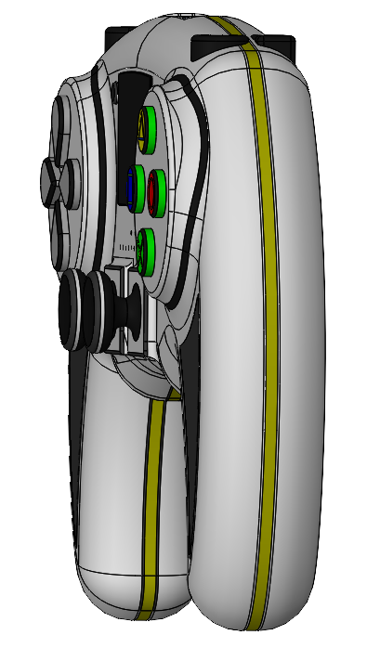

### left side view of the gamepad:

### Top view of the gamepad:

### Bottom view of the gamepad:

## Render Images

### Render image of the original gamepad

### Customised Version of the gamepad

## Sustainability report

